

**Servlet technology is used to create web application (resides at server side and generates dynamic web page).**

**Servlet technology is robust and scalable because of java language. Before Servlet,CGI (Common Gateway Interface) scripting language was popular as a server-side programming language. But there was many disadvantages of this technology. We have discussed these disadvantages below.**

**There are many interfaces and classes in the servlet APIsuch as Servlet, GenericServlet, HttpServlet, ServletRequest, ServletResponse etc.**

**What is a Servlet?**

**Servlet can be described in many ways, depending on the context.**

* **Servlet is a technology i.e. used to create web application.**
* **Servlet is an API that provides many interfaces and classes including documentations.**
* **Servlet is an interface that must be implemented for creating any servlet.**
* **Servlet is a class that extend the capabilities of the servers and respond to the incoming request. It can respond to any type of requests.**
* **Servlet is a web component that is deployed on the server to create dynamic web page.**

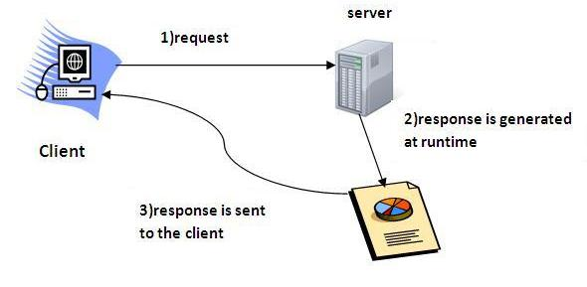

### What is web application?

**A web application is an application accessible from the web. A web application is composed of web components like Servlet, JSP, Filter etc. and other components such as HTML. The web components typically execute in Web Server and respond to HTTP request.**

### CGI(Commmon Gateway Interface)

**CGI technologyenables the web server to call an external program and pass HTTP request information to the external program to process the request. For each request, it starts a new process.**

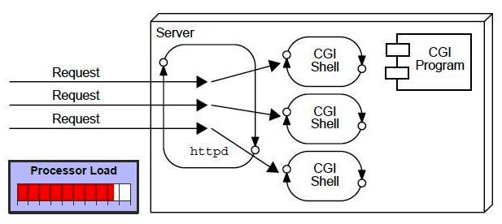

### Disadvantages of CGI

**There are many problems in CGI technology:**

1. **If number of clients increases, it takes more time for sending response.**
2. **For each request, it starts a process and Web server is limited to start processes.**
3. **It uses platform dependent language e.g. C, C++, perl.**

### Advantage of Servlet

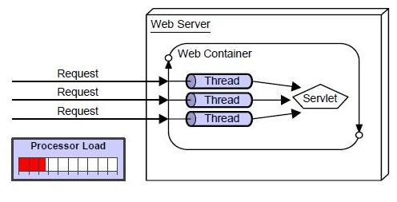

**There are many advantages of servlet over CGI. The web container creates threads for handling the multiple requests to the servlet. Threads have a lot of benefitsover the Processes such as they share a common memory area, lightweight, cost of communication between the threads are low. The basic benefits of servlet are as follows:**

1. **better performance: because it creates a thread for each request not process.**
2. **Portability: because it uses java language.**
3. **Robust: Servlets are managed by JVM so we don't need to worry about memory leak, garbage collection etc.**
4. **Secure: because it uses java language..**

**Web Terminology**

|  |  |
| --- | --- |
| **Servlet Terminology** | **Description** |
| [**Website: static vs dynamic**](http://www.javatpoint.com/web-terminology) | **It is a collection of related web pages that may contain text, images, audio and video.** |
| [**HTTP**](http://www.javatpoint.com/web-terminology) | **It is the data communication protocol used to establish communication between client and server.** |
| [**HTTP Requests**](http://www.javatpoint.com/web-terminology) | **It is the request send by the computer to a web server that contains all sorts of potentially interesting information.** |
| [**Get vs Post**](http://www.javatpoint.com/web-terminology) | **It give the difference between GET and POST request.** |
| [**Container**](http://www.javatpoint.com/web-terminology) | **It is used in java for dynamically generate the web pages on the server side.** |
| [**Server: Web vs Application**](http://www.javatpoint.com/web-terminology) | **It is used to manage the network resources and for running the program or software that provides services.** |
| [**Content Type**](http://www.javatpoint.com/web-terminology) | **It is HTTP header that provides the description about what are you sending to the browser.** |

**Website**

**Website is a collection of related web pages that may contain text, images, audio and video. The first page of a website is called home page. Each website has specific internet address (URL) that you need to enter in your browser to access a website.**

**Website is hosted on one or more servers and can be accessed by visiting its homepage using a computer network. A website is managed by its owner that can be an individual, company or an organization.**



**A website can be of two types:**

* **Static Website**
* **Dynamic Website**

**Static website**

**Static website is the basic type of website that is easy to create. You don't need web programming and database design to create a staticwebsite. Its web pages are coded in HTML.**

**The codes are fixed for each page so the information contained in the page does not change and it looks like a printed page.**

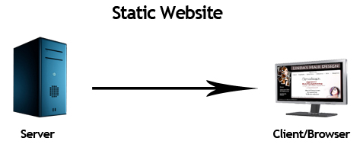

**Dynamic website**

**Dynamic website is a collectionof dynamic web pages whose content changes dynamically. It accesses content from a database or Content Management System (CMS). Therefore, when you alter or update the content of the database, the content of the website is also altered or updated.**

**Dynamic websiteuses client-side scripting or server-side scripting, or both to generate dynamic content.**

**Client side scripting generatescontent at the client computer on the basis of user input. The web browser downloads the web page from the server and processes the code within the page to render information to the user.**

**In server side scripting, the software runs on the server and processing is completed in the server then plain pages are sent to the user.**

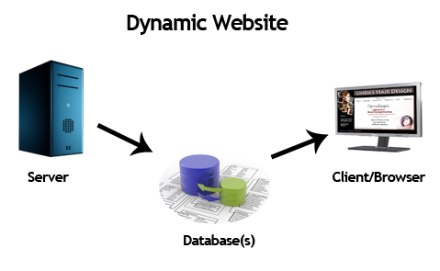

**Static vs Dynamic website**

|  |  |
| --- | --- |
| **Static Website** | **Dynamic Website** |
| **Prebuilt content is same every time the page is loaded.** | **Content is generated quickly and changes regularly.** |
| **It uses the HTML code for developing a website.** | **It uses the server side languages such as PHP,SERVLET, JSP,and ASP.NET etc. for developing a website.** |
| **It sends exactly the same response for every request.** | **It may generate different HTML for each of the request.** |
| **The content is only changes when someone publishes and updates the file (sends it to the web server).** | **The page contains "server-side" code it allows the server togenerate the unique content when the page is loaded.** |
| **Flexibility is the main advantage of static website.** | **Content Management System (CMS) is the main advantage of dynamic website.** |

**HTTP (Hyper Text Transfer Protocol)**

**The Hypertext Transfer Protocol (HTTP) is application-level protocol for collaborative, distributed, hypermedia information systems. It is the data communication protocol used to establish communication between client and server.**

**HTTP is TCP/IPbased communication protocol, which is used to deliver the data like image files, queryresults, HTML files etc on the World Wide Web (WWW)with the default port is TCP 80. It provides the standardized way for computers to communicate with each other.**

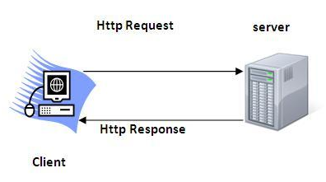

**The Basic Characteristics of HTTP (Hyper Text Transfer Protocol):**

* **It is the protocol that allows web servers and browsers to exchange data over the web.**
* **It is a request response protocol.**
* **It uses the reliable TCP connections by default on TCP port 80.**
* **It is stateless means each request is considered as the new request. In other words, server doesn't recognize the user by default.**

**The Basic Features of HTTP (Hyper Text Transfer Protocol):**

**There are three fundamental features that make the HTTP a simple and powerful protocol used for communication:**

* **HTTP is media independent: It refers to any type of media content can be sent by HTTP as long as both the server and the client can handle the data content.**
* **HTTP is connectionless: It is a connectionless approach in which HTTP client i.e., a browserinitiates the HTTP request and after the request is sends the clientdisconnectsfrom server and waits for the response.**
* **HTTP is stateless: The client and server are aware of each other during a current request only. Afterwards, both of them forget each other. Due to the stateless nature of protocol, neither the client nor the server can retain the information about different request across the web pages.**

**The Basic Architecture of HTTP (Hyper Text Transfer Protocol):**

**The below diagram represents the basic architecture of web application and depicts where HTTP stands:**

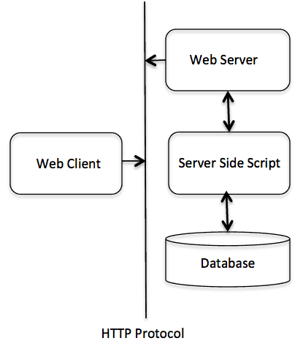

**HTTP is request/response protocol which is based on client/server based architecture. In this webbrowser, search engines, etc behaves as a HTTP clients, and the Web server like Servlet behaves as a server.**

**HTTP Requests**

**The request sends by the computer to a web server that contains all sorts of potentially interesting information is known as HTTP requests.**

**The HTTP client sends the request to the server in the form of request message which includes following information:**

* **The Request-line**
* **The analysis of source IP address, proxy and port**
* **The analysis of destination IP address, protocol, port and host**
* **The Requested URI (Uniform Resource Identifier)**
* **The Request method and Content**
* **The User-Agent header**
* **The Connection control header**
* **The Cache control header**

**The HTTP request method indicates the method to be performed on the resource identified by the Requested URI (Uniform Resource Identifier). This method is case-sensitive and should be used in uppercase.**

**The HTTP request methods are:**

|  |  |
| --- | --- |
| **HTTP Request** | **Description** |
| **GET** | **Asks to get the resource at the requested URL.** |
| **POST** | **Asks the server to accept the body info attached. It is like GET request with extra info sent with the request.** |
| **HEAD** | **Asks for only the header part of whatever a GET would return. Just like GETbut with no body.** |
| **TRACE** | **Asks for the loopback of the request message, for testing or troubleshooting.** |
| **PUT** | **Says to put the enclosed info (the body) at the requested URL.** |
| **DELETE** | **Says to delete the resource at the requested URL.** |
| **OPTIONS** | **Asks for a list of the HTTP methods to which the thing at the request URL can respond** |

|  |  |  |  |  |  |  |  |  |  |  |  |  |
| --- | --- | --- | --- | --- | --- | --- | --- | --- | --- | --- | --- | --- |
| **Get vs. Post**  **There are many differences between the Get and Post request. Let's see these differences:**   |  |  | | --- | --- | | **GET** | **POST** | | **1) In case of Get request, only limited amount of data can besent because data is sent in header.** | **In case of post request, large amount ofdata can be sent because data is sent in body.** | | **2) Get request is not secured because data is exposed in URL bar.** | **Post request is secured because data is not exposed in URL bar.** | | **3) Get request can be bookmarked.** | **Post request cannot be bookmarked.** | | **4) Get request is idempotent . It means secondrequest will be ignored until response of first request is delivered** | **Post request is non-idempotent.** | | **5) Get request is more efficient and used more than Post.** | **Post request is less efficient and used less than get.** |   **GET and POST**  **Two common methods for the request-response between a server and client are:**   * **GET-It requests the data from a specified resource** * **POST- It submits the processed data to a specified resource**   **Anatomy of Get Request**  **The query string (name/value pairs) is sent inside the URL of a GET request:**   1. **GET /RegisterDao.jsp?name1=value1&name2=value2**   **As we know that data is sent in request header in case of get request. It is the default request type. Let's see what information is sent to the server.**  **Servlet Request6**  **Some other features of GET requests are:**   * **It remains in the browser history** * **It can be bookmarked** * **It can be cached** * **It have length restrictions** * **It should never be used when dealing with sensitive data** * **It should only be used for retrieving the data**   **Anatomy of Post Request**  **The query string (name/value pairs) is sent in HTTP message body for a POST request:**   1. **POST/RegisterDao.jsp HTTP/1.1** 2. **Host: www. javatpoint.com** 3. **name1=value1&name2=value2**   **As we know, in case of post request original data is sent in message body. Let's see how information is passed to the server in case of post request.**  **Servlet Request7**  **Some other features of POST requests are:**   * **This requests cannot be bookmarked** * **This requests have no restrictions on length of data** * **This requests are never cached** * **This requests do not remains in the browser history** |

**Servlet Container**

**It provides the runtimeenvironment for JavaEE (j2ee) applications. The client/user can request only astatic WebPages from the server. If the user wants to readthe web pages as per input then the servlet container is used in java.**

**The servlet container is used in java for dynamically generate the web pageson the server side. Therefore the servlet container is the part of a web server that interacts with the servlet for handling the dynamic web pages from the client.**

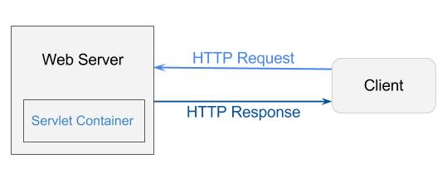

**Servlet Container States**

**The servlet container is the part of web server which can be run in a separate process. We can classify the servlet container states in three types:**

* **Standalone: It is typical Java-based servers in which the servlet container and the web servers are the integral part of a single program. For example:- Tomcat running by itself**
* **In-process: It is separated from the web server, because a different program is runs within theaddress space of the main server as a plug-in. For example:- Tomcat running inside the JBoss.**
* **Out-of-process: The web server and servlet container are different programs which are run in a different process. For performing the communications between them, web server uses the plug-in provided by the servlet container.**

**The Servlet Container performs many operations that are given below:**

* **Life Cycle Management**
* **Multithreaded support**
* **Object Pooling**
* **Security etc.**

**Server: Webvs. Application**

**Server is a device or a computer program that accepts and responds to the request made by other program, known as client. It is used to manage the networkresources and for running the program or software that provides services.**

**There are two types of servers:**

1. **Web Server**
2. **Application Server**

**Web Server**

**Web server contains only web or servlet container. It can be used for servlet, jsp, struts, jsf etc. It can'tbe used for EJB.**

**It is a computer where the web content can be stored. In general web server can be used to host the web sites but there also used some other web servers also such as FTP, email, storage, gaming etc.**

**Examples of Web Servers are: Apache Tomcat and Resin.**

**Web Server Working**

**It can respond to the client request in either of the following two possible ways:**

* **Generatingresponse by using the script and communicating with database.**
* **Sending file to the client associated with the requested URL.**

**The block diagram representation of Web Server is shown below:**

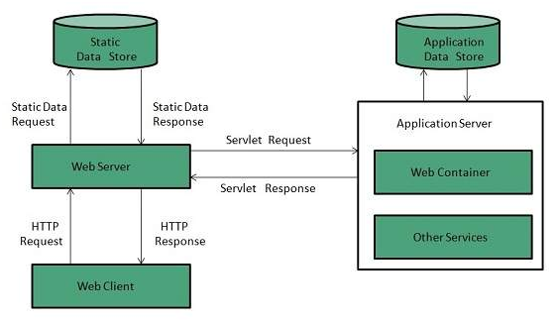

**Important points**

* **If the requested web page at the client side is not found, then web server will sends the HTTP response: Error 404 Not found.**
* **When the web server searching the requested page if requested page is found then it will send to the client with an HTTP response.**
* **If the client requests some other resources then webserver will contact to application server and data is store for constructing the HTTP response.**

**Application Server**

**Application server contains Web and EJB containers. It can be used for servlet, jsp, struts, jsf, ejb etc. It is a component based product that lies in the middle-tier of a servercentric architecture.**

**It provides the middleware services for state maintenance and security, along with persistence and data access. It is a type of server designed to install,operate and host associated services andapplications for the IT services, end users and organizations.**

**The block diagram representation of Application Server is shown below:**

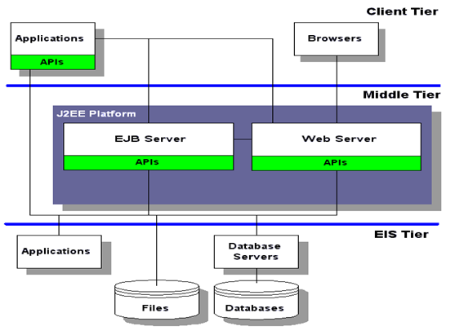

**The Example of Application Servers are:**

1. **JBoss: Open-source server from JBoss community.**
2. **Glassfish: Provided by Sun Microsystem. Now acquired by Oracle.**
3. **Weblogic: Provided by Oracle. It more secured.**
4. **Websphere: Provided by IBM.**

**Content Type**

**Content Type is also known as MIME (Multipurpose internet Mail Extension) Type. It is a HTTPheader that provides the description about what are you sending to the browser.**

**MIME is an internet standard that is used for extending the limited capabilities of email by allowing the insertion of sounds, images and text in a message.**

**The features provided by MIME to the emailservices are as given below:**

* **It supports the non-ASCII characters**
* **It supports the multiple attachments in a single message**
* **It supports the attachment which contains executable audio, images and video files etc.**
* **It supports the unlimited message length.**

**List of Content Types**

**There are many content types. The commonly used content types are given below:**

* **text/html**
* **text/plain**
* **application/msword**
* **application/vnd.ms-excel**
* **application/jar**
* **application/pdf**
* **application/octet-stream**
* **application/x-zip**
* **images/jpeg**
* **images/png**
* **images/gif**
* **audio/mp3**
* **video/mp4**
* **video/quicktime etc.**

# Servlet API

**The javax.servlet and javax.servlet.http packagesrepresent interfaces and classes for servlet api.**

**The javax.servlet package contains many interfaces and classes that are used by the servlet or web container. These are not specific to any protocol.**

**The javax.servlet.http package contains interfaces and classes that are responsible for http requests only.**

**Let's see what are the interfaces of javax.servlet package.**

### Interfaces in javax.servlet package

**There are many interfaces in javax.servlet package. They are as follows:**

1. **Servlet**
2. **ServletRequest**
3. **ServletResponse**
4. **RequestDispatcher**
5. **ServletConfig**
6. **ServletContext**
7. **SingleThreadModel**
8. **Filter**
9. **FilterConfig**
10. **FilterChain**
11. **ServletRequestListener**
12. **ServletRequestAttributeListener**
13. **ServletContextListener**
14. **ServletContextAttributeListener**

### Classes in javax.servlet package

**There are many classes in javax.servlet package. They are as follows:**

1. **GenericServlet**
2. **ServletInputStream**
3. **ServletOutputStream**
4. **ServletRequestWrapper**
5. **ServletResponseWrapper**
6. **ServletRequestEvent**
7. **ServletContextEvent**
8. **ServletRequestAttributeEvent**
9. **ServletContextAttributeEvent**
10. **ServletException**
11. **UnavailableException**

### Interfaces in javax.servlet.http package

**There are many interfaces in javax.servlet.http package. They are as follows:**

1. **HttpServletRequest**
2. **HttpServletResponse**
3. **HttpSession**
4. **HttpSessionListener**
5. **HttpSessionAttributeListener**
6. **HttpSessionBindingListener**
7. **HttpSessionActivationListener**
8. **HttpSessionContext (deprecated now)**

### Classes in javax.servlet.http package

**There are many classes in javax.servlet.http package. They are as follows:**

1. **HttpServlet**
2. **Cookie**
3. **HttpServletRequestWrapper**
4. **HttpServletResponseWrapper**
5. **HttpSessionEvent**
6. **HttpSessionBindingEvent**
7. **HttpUtils (deprecated now)**

# Servlet Interface

### Servlet Example by implementing Servlet interface

**Let's see the simple example of servlet by implementing the servlet interface.**

### It will be better if you learn it after visiting steps to create a servlet.

***File: First.java***

1. **import java.io.*;**
2. **import javax.servlet.*;**
4. **public class First implements Servlet{**
5. **ServletConfig config=null;**
7. **public void init(ServletConfig config){**
8. **this.config=config;**
9. **System.out.println("servlet is initialized");**
10. **}**
12. **public void service(ServletRequest req,ServletResponse res)**
13. **throws IOException,ServletException{**
15. **res.setContentType("text/html");**
17. **PrintWriter out=res.getWriter();**
18. **out.print("<html><body>");**
19. **out.print("<b>hello simple servlet</b>");**
20. **out.print("</body></html>");**
22. **}**
23. **public void destroy(){System.out.println("servlet is destroyed");}**
24. **public ServletConfig getServletConfig(){return config;}**
25. **public String getServletInfo(){return "copyright 2007-1010";}**
27. **}**

**Servlet interface provides common behaviour to all the servlets.**

**Servlet interface needs to be implemented for creating any servlet (either directly or indirectly). It provides 3 life cycle methods that are used to initialize the servlet, to service the requests, and to destroy the servlet and 2 non-life cycle methods.**

### Methods of Servlet interface

**There are 5 methods in Servlet interface. The init, service and destroy are the life cycle methods ofservlet. These are invoked by the web container.**

|  |  |
| --- | --- |
| **Method** | **Description** |
| **public void init(ServletConfig config)** | **initializes the servlet. It is the life cycle methodof servlet and invoked by the web container only once.** |
| **public void service(ServletRequest request,ServletResponse response)** | **provides response for the incoming request. It is invoked at each request by the web container.** |
| **public void destroy()** | **is invoked only once and indicates that servlet is being destroyed.** |
| **public ServletConfig getServletConfig()** | **returns the object of ServletConfig.** |
| **public String getServletInfo()** | **returns information about servlet such as writer, copyright, version etc** |

# GenericServlet class

**GenericServlet class implements Servlet, ServletConfig and Serializableinterfaces. It provides the implementation of all the methods of these interfaces except the service method.**

**GenericServlet class can handle any type of request so it is protocol-independent.**

**You may create a generic servlet by inheriting the GenericServlet class and providing the implementation of the service method.**

### Methods of GenericServlet class

**There are many methods in GenericServlet class. They are as follows:**

1. **public void init(ServletConfig config) is used to initialize the servlet.**
2. **public abstract void service(ServletRequest request, ServletResponse response) provides service for the incoming request. It is invoked at each time when user requests for a servlet.**
3. **public void destroy() is invoked only once throughout the life cycle and indicates that servlet is being destroyed.**
4. **public ServletConfig getServletConfig() returns the object of ServletConfig.**
5. **public String getServletInfo() returns information about servlet such as writer, copyright, version etc.**
6. **public void init() it is a convenientmethod for the servlet programmers, now there is no need to call super.init(config)**
7. **public ServletContext getServletContext() returns the object of ServletContext.**
8. **public String getInitParameter(String name) returns the parameter value for the given parameter name.**
9. **public Enumeration getInitParameterNames() returns all the parameters defined in the web.xml file.**
10. **public String getServletName() returns the name of the servlet object.**
11. **public void log(String msg) writes the given message in the servlet log file.**
12. **publicvoid log(String msg,Throwable t) writes the explanatory message in the servlet log file and a stack trace.**

### Servlet Example by inheriting the GenericServlet class

**Let's see the simple example of servlet by inheriting the GenericServlet class.**

### It will be better if you learn it after visiting steps to create a servlet.

***File: First.java***

1. **import java.io.*;**
2. **import javax.servlet.*;**
4. **public class First extends GenericServlet{**
5. **public void service(ServletRequest req,ServletResponse res)**
6. **throws IOException,ServletException{**
8. **res.setContentType("text/html");**
10. **PrintWriter out=res.getWriter();**
11. **out.print("<html><body>");**
12. **out.print("<b>hello generic servlet</b>");**
13. **out.print("</body></html>");**
15. **}**
16. **}**

# HttpServlet class

|  |
| --- |
| **The HttpServlet class extends the GenericServletclass and implements Serializable interface. It provides http specific methods such as doGet, doPost, doHead, doTrace etc.** |

### Methods of HttpServlet class

**There are many methods in HttpServlet class. They are as follows:**

1. **public void service(ServletRequest req,ServletResponse res) dispatches the request to the protected service method by convertingthe request and response object into http type.**
2. **protected void service(HttpServletRequest req, HttpServletResponse res) receives the requestfrom the service method, and dispatches the request to the doXXX() method depending on the incoming http request type.**
3. **protected void doGet(HttpServletRequest req, HttpServletResponse res) handles the GETrequest. It is invoked by the web container.**
4. **protected void doPost(HttpServletRequest req, HttpServletResponse res) handles the POST request. It is invoked by the web container.**
5. **protected void doHead(HttpServletRequest req, HttpServletResponse res) handles the HEADrequest. It is invoked by the web container.**
6. **protected void doOptions(HttpServletRequest req, HttpServletResponse res) handles the OPTIONS request. It is invoked by the web container.**
7. **protected void doPut(HttpServletRequest req, HttpServletResponse res) handles the PUTrequest. It is invoked by the web container.**
8. **protected void doTrace(HttpServletRequest req, HttpServletResponse res) handles the TRACErequest. It is invoked by the web container.**
9. **protected void doDelete(HttpServletRequest req, HttpServletResponse res) handles the DELETE request. It is invoked by the web container.**
10. **protected long getLastModified(HttpServletRequest req) returns the time when HttpServletRequest was last modified since midnight January 1, 1970 GMT.**

**Life Cycle of a Servlet (Servlet Life Cycle)**

**The web container maintains the life cycle of a servlet instance. Let's see the life cycle of the servlet:**

1. **Servlet class is loaded.**
2. **Servlet instance is created.**
3. **init method is invoked.**
4. **service method is invoked.**
5. **destroy method is invoked.**

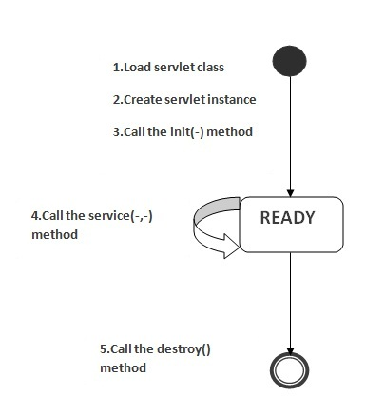

**As displayed in the above diagram, there are three states of a servlet: new, ready and end. The servletis in new state if servlet instance is created. After invoking the init() method, Servlet comes in theready state. In the ready state,servlet performs all the tasks. When the web container invokes the destroy() method, it shifts to the end state.**

### 1) Servlet class is loaded

**The classloader is responsible to load the servlet class. The servlet class is loaded when the first request for the servlet is received by the web container.**

### 2) Servlet instance is created

**The web container creates the instance of a servlet after loading the servlet class. The servlet instance is created only once in the servlet life cycle.**

### 3) init method is invoked

|  |
| --- |
| **The web container calls the init method only onceafter creating the servlet instance. The init methodis used to initialize the servlet. It is the life cycle method of the javax.servlet.Servlet interface. Syntax of the init method is given below:** |

1. **public void init(ServletConfig config) throws ServletException**

### 4) service method is invoked

**The web container calls the service method each time when request for the servlet is received. If servlet is not initialized, it follows the first three steps as described above then calls the service method. If servlet is initialized, it calls the service method. Notice that servlet is initialized only once. The syntax of the service method of the Servlet interface is given below:**

1. **public void service(ServletRequest request, ServletResponse response)**
2. **throws ServletException, IOException**

### 5) destroy method is invoked

**The web container calls the destroy method before removing the servlet instance from the service. It gives the servlet an opportunity to clean up any resource for example memory, thread etc. The syntax of the destroy method of the Servlet interface is given below:**

1. **public void destroy()**

**Steps to create a servlet example**

**There are given 6 steps to create a servlet example. These steps are required for all the servers.**

**The servlet example can be created by three ways:**

1. **By implementing Servlet interface,**
2. **By inheriting GenericServlet class, (or)**
3. **By inheriting HttpServlet class**

**The mostly used approach is by extending HttpServlet because it provides http request specificmethod such as doGet(), doPost(), doHead() etc.**

**Here, we are going to use apache tomcat server in this example. The steps are as follows:**

1. **Create a directory structure**
2. **Create a Servlet**
3. **Compile the Servlet**
4. **Create a deployment descriptor**
5. **Start the server and deploy the project**
6. **Access the servlet**

### 1)Create a directory structures

**The directory structure defines that where to put the different types of files so that web container may get the information and respond to the client.**

**The Sun Microsystem defines a unique standard to be followed by all the server vendors. Let's see the directory structure that must be followed to create the servlet.**

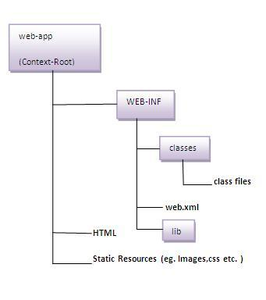

**As you can see that the servlet class file must be in the classes folder. The web.xml file must be under the WEB-INF folder.**

### 2)Create a Servlet

|  |
| --- |
| **There are three ways to create the servlet.**   1. **By implementing the Servlet interface** 2. **By inheriting the GenericServlet class** 3. **By inheriting the HttpServlet class**   **The HttpServlet class is widely used to create the servlet because it provides methods to handlehttp requests such as doGet(), doPost, doHead() etc.** |
| **In this example we are going to create a servlet that extends the HttpServlet class. In this example, we are inheriting the HttpServlet class and providing the implementation of the doGet() method. Notice that get request is the default request.** |

**DemoServlet.java**

1. **import javax.servlet.http.*;**
2. **import javax.servlet.*;**
3. **import java.io.*;**
4. **public class DemoServlet extends HttpServlet{**
5. **public void doGet(HttpServletRequest req,HttpServletResponse res)**
6. **throws ServletException,IOException**
7. **{**
8. **res.setContentType("text/html");//setting the content type**
9. **PrintWriter pw=res.getWriter();//get the stream to write the data**
11. **//writing html in the stream**
12. **pw.println("<html><body>");**
13. **p`w.println("Welcome to servlet");**
14. **pw.println("</body></html>");**
16. **pw.close();//closing the stream**
17. **}}**

### 3)Compile the servlet

**For compiling the Servlet, jar file is required to be loaded. Different Servers provide different jar files:**

|  |  |
| --- | --- |
| **Jar file** | **Server** |
| **1) servlet-api.jar** | **Apache Tomcat** |
| **2) weblogic.jar** | **Weblogic** |
| **3) javaee.jar** | **Glassfish** |
| **4) javaee.jar** | **JBoss** |

### Two ways to load the jar file

1. **set classpath**
2. **paste the jar file in JRE/lib/ext folder**

**Put the java file in any folder. After compiling the java file, paste the class file of servlet in WEB-INF/classes directory.**

### 4)Create the deployment descriptor (web.xml file)

**The deployment descriptor is an xml file, from which Web Container gets the information about the servet to be invoked.**

**The web container uses the Parser to get the information from the web.xml file. There are many xml parsers such as SAX, DOM and Pull.**

**There are many elements in the web.xml file. Here is given some necessary elements to run the simple servlet program.**

**web.xml file**

1. **<web-app>**
3. **<servlet>**
4. **<servlet-name>sonoojaiswal</servlet-name>**
5. **<servlet-class>DemoServlet</servlet-class>**
6. **</servlet>**
8. **<servlet-mapping>**
9. **<servlet-name>sonoojaiswal</servlet-name>**
10. **<url-pattern>/welcome</url-pattern>**
11. **</servlet-mapping>**
13. **</web-app>**

### Description of the elements of web.xml file

**There are too many elements in the web.xml file. Here is the illustration of some elements that is used in the above web.xml file. The elements are as follows:**

|  |
| --- |
| **<web-app> represents the whole application.** |
| **<servlet> is sub element of <web-app> and represents the servlet.** |
| **<servlet-name> is sub element of <servlet> represents the name of the servlet.** |
| **<servlet-class> is sub element of <servlet> represents the class of the servlet.** |
| **<servlet-mapping> is sub element of <web-app>. It is used to map the servlet.** |
| **<url-pattern> is sub element of <servlet-mapping>. This pattern is used at client side to invoke theservlet.** |

### 5)Start the Server and deploy the project

**To start Apache Tomcat server, double click on the startup.bat file under apache-tomcat/bin directory.**

### One Time Configuration for Apache Tomcat Server

**You need to perform 2 tasks:**

1. **set JAVA_HOME or JRE_HOME in environment variable (It is required to start server).**
2. **Change the port number of tomcat (optional). It is required if another server is running on same port (8080).**

#### 1) How to set JAVA_HOME in environment variable?

**To start Apache Tomcat server JAVA_HOME and JRE_HOME must be set in Environment variables.**

**Go to My Computer properties -> Click on advanced tab then environment variables -> Click on the new tab of user variable -> Write JAVA_HOME in variable name and paste the path of jdk folder in variable value -> ok -> ok -> ok.**

**Go to My Computer properties:**

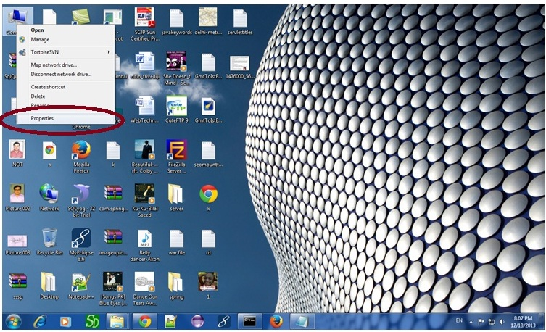

**Click on advanced system settings tab then environment variables:**

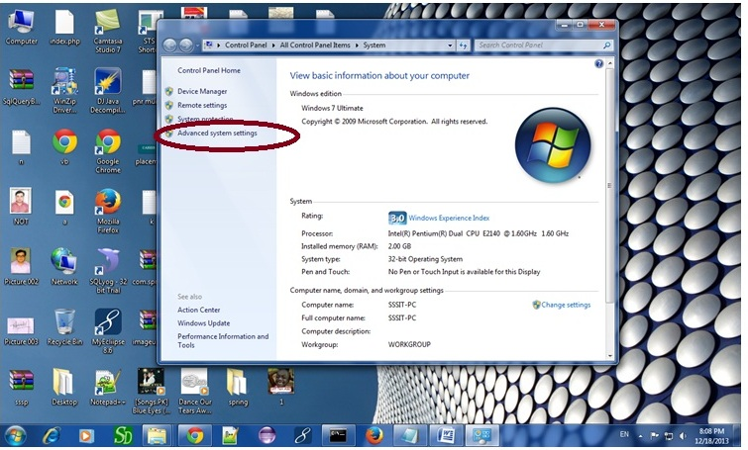

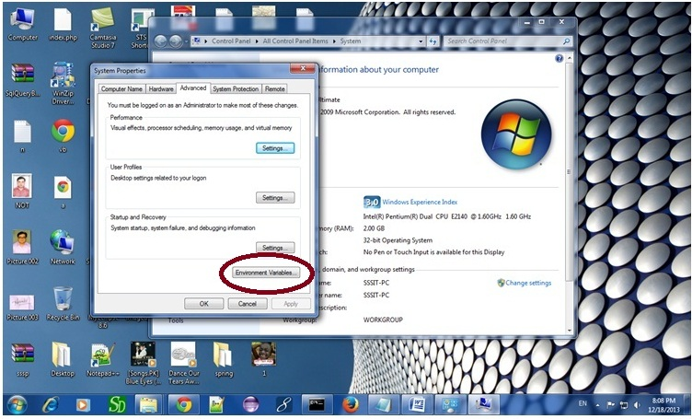

**Click on the new tab of user variable or system variable:**

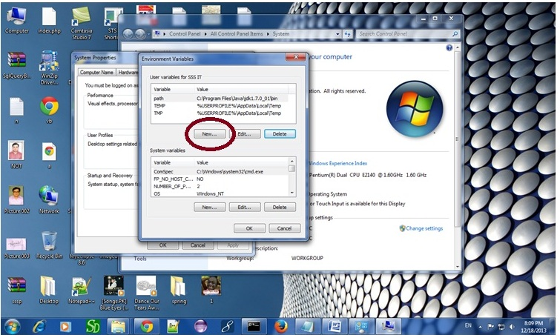

**Write JAVA_HOME in variable name and paste the path of jdk folder in variable value:**

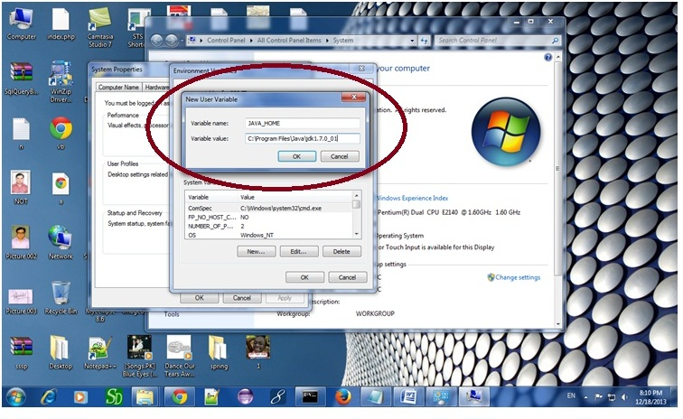

**There must not be semicolon (;) at the end of the path.**

|  |
| --- |
| **After setting the JAVA_HOME double click on the startup.bat file in apache tomcat/bin.** |
| **Note: There are two types of tomcat available:**   1. **Apache tomcat that needs to extract only (no need to install)** 2. **Apache tomcat that needs to install** |
| **It is the example of apache tomcat that needs to extract only.** |

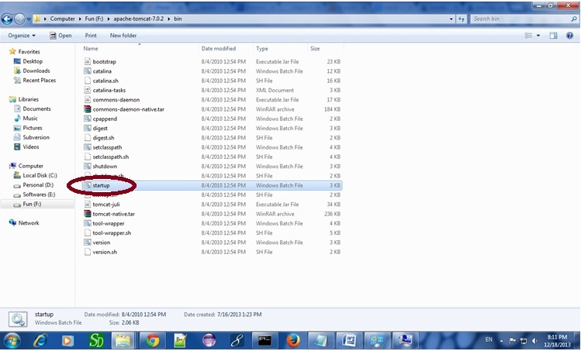

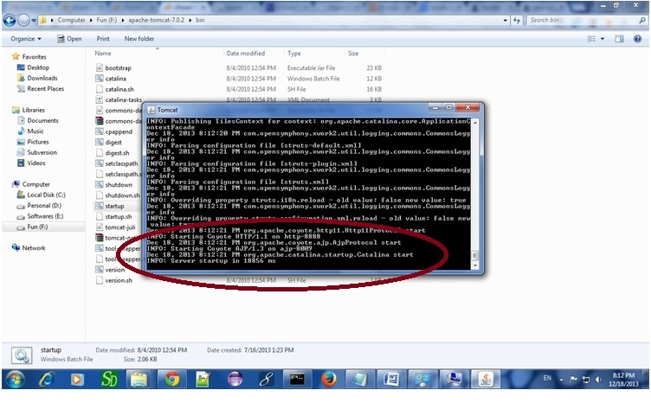

**Now server is started successfully.**

### 2) How to change port number of apache tomcat

**Changing the port number is required if there is another server running on the same system with same port number.Suppose you have installed oracle, you need to change the port number of apache tomcat because both have the default port number 8080.**

**Open server.xml file in notepad. It is located inside the apache-tomcat/conf directory . Change the Connector port = 8080 and replace 8080 by any four digit number instead of 8080. Let us replace it by 9999 and save this file.**

### 5) How to deploy the servlet project

**Copy the project and paste it in the webapps folder under apache tomcat.**

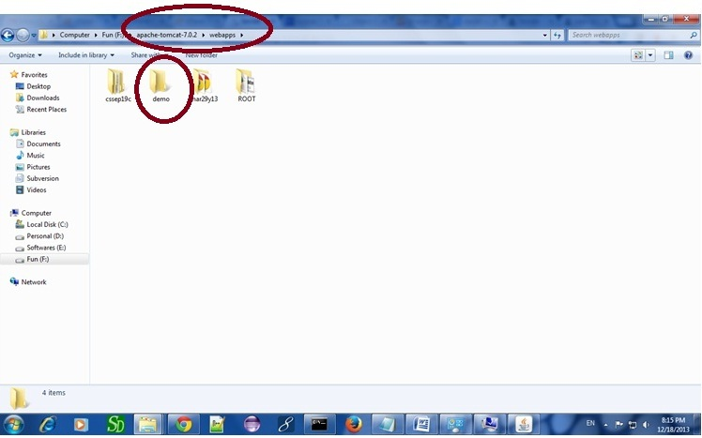

**But there are several ways to deploy the project. They are as follows:**

* **By copying the context(project) folder into the webapps directory**
* **By copying the war folder into the webapps directory**
* **By selecting the folder path from the server**
* **By selecting the war file from the server**

**Here, we are using the first approach.**

**You can also create war file, and paste it inside the webapps directory. To do so, you need to use jar tool to create the war file. Go inside the project directory (before the WEB-INF), then write:**

1. **projectfolder> jar cvf myproject.war \***

**Creating war file has an advantage that moving the project from one location to another takes less time.**

### 6) How to access the servlet

**Open broser and write http://hostname:portno/contextroot/urlpatternofservlet. For example:**

1. **http://localhost:9999/demo/welcome**

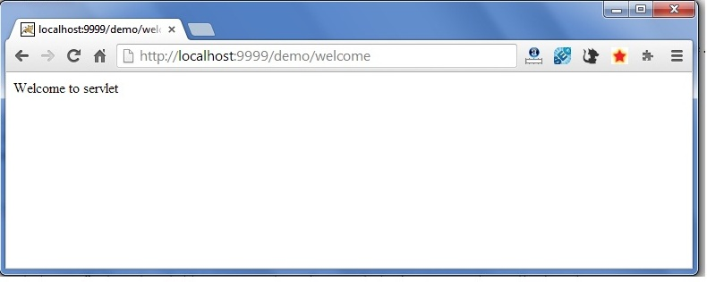

**How Servlet works?**

**It is important to learn how servlet works for understanding the servlet well. Here, we are going to get the internal detail about the first servlet program.**

**The server checks if the servlet is requested for the first time.**

**If yes, web container does the following tasks:**

* **loads the servlet class.**
* **instantiates the servlet class.**
* **calls the init method passing the ServletConfig object**

**else**

* **calls the service method passing request and response objects**

**The web container calls the destroy method when it needs to remove the servlet such as at time of stopping server or undeploying the project.**

### How web container handles the servlet request?

**The web container is responsible to handle the request. Let's see how it handles the request.**

* **maps the request with the servlet in the web.xml file.**
* **creates request and response objects for this request**
* **calls the service method on the thread**
* **The public service method internally calls the protected service method**
* **The protected service method calls the doGet method depending on the type of request.**
* **The doGet method generates the response and it is passed to the client.**
* **After sending the response, the web container deletes the request and response objects. The thread is contained in the thread pool or deleted depends on the server implementation.**

### What is written inside the public service method?

**The public service method converts the ServletRequest object into the HttpServletRequest type and ServletResponse object into the HttpServletResponse type. Then, calls the service method passing these objects. Let's see the internal code:**

1. **public void service(ServletRequest req, ServletResponse res)**
2. **throws ServletException, IOException**
3. **{**
4. **HttpServletRequest request;**
5. **HttpServletResponse response;**
6. **try**
7. **{**
8. **request = (HttpServletRequest)req;**
9. **response = (HttpServletResponse)res;**
10. **}**
11. **catch(ClassCastException e)**
12. **{**
13. **throw new ServletException("non-HTTP request or response");**
14. **}**
15. **service(request, response);**
16. **}**

### What is written inside the protected service method?

**The protected service method checks the type of request, if request type is get, it calls doGet method, if request type is post, it calls doPost method, so on. Let's see the internal code:**

1. **protected void service(HttpServletRequest req, HttpServletResponse resp)**
2. **throws ServletException, IOException**
3. **{**
4. **String method = req.getMethod();**
5. **if(method.equals("GET"))**
6. **{**
7. **long lastModified = getLastModified(req);**
8. **if(lastModified == -1L)**
9. **{**
10. **doGet(req, resp);**
11. **}**
12. **....**
13. **//rest of the code**
14. **}**
15. **}**

**War File**

**A war (web archive) File contains files of a web project. It may have servlet, xml, jsp, image, html, css, js etc. files.**

**Here, we will discuss what is war file, how to create war file, how to deploy war file and how to extract war file.**

**What is war file?**

**web archive (war) file contains all the contents of a web application. It reduces the time duration for transferring file.**

**Advantage of war file**

**saves time: The war filecombines all the files into a single unit. So it takes less time while transferring file from client to server.**

**How to create war file?**

**To create war file, you need to use jar tool of JDK. You need to use -c switch of jar, to create the war file.**

**Go inside the project directory of your project (outside the WEB-INF), then write the following command:**

1. **jar -cvf projectname.war \***

**Here, -c is used to create file, -v to generate the verbose output and -f to specify the arhive file name.**

**The * (asterisk) symbol signifies that all the files of this directory (including sub directory).**

## How to deploy the war file?

**There are two ways to deploy the war file.**

1. **By server console panel**
2. **By manually having the war file in specific folder of server.**

**If you want to deploy the war file in apache tomcat server manually, go to the webapps directory of apache tomcat and paste the war file here.**

**Now, you are able to access the web project through browser.**

#### Note: server will extract the war file internally.

## How to extract war file manually?

**To extract the war file, you need to use -x switch of jar tool of JDK. Let's see the command to extract the war file.**

1. **jar -xvf projectname.war**

**welcome-file-list in web.xml**

**The welcome-file-list element of web-app, is used to define a list of welcome files. Its sub element is welcome-file that is used to define the welcome file.**

**A welcome file is the file that is invoked automatically by the server, if you don't specify any file name.**

**By default server looks for the welcome file in following order:**

1. **welcome-file-list in web.xml**
2. **index.html**
3. **index.htm**
4. **index.jsp**

**If none of these files are found, server renders 404 error.**

**If you have specified welcome-file in web.xml, and all the files index.html, index.htm and index.jsp exists, priority goes to welcome-file.**

**If welcome-file-list entry doesn't exist in web.xml file, priority goes to index.html file then index.htm and at last index.jsp file.**

**Let's see the web.xml file that defines the welcome files.**

***web.xml***

1. **<web-app>**
2. **....**
4. **<welcome-file-list>**
5. **<welcome-file>home.html</welcome-file>**
6. **<welcome-file>default.html</welcome-file>**
7. **</welcome-file-list>**
8. **</web-app>**

**Now, home.html and default.html will be the welcome files.**

**If you have the welcome file, you can directory invoke the project as given below:**

1. **http://localhost:8888/myproject**

**As you can see, we have not specified any file name after the project.**

# load on startup in web.xml

**The load-on-startup element of web-app loads the servlet at the time of server start if value is positive. It is also known as pre initialization of servlet.**

**You can pass positive and negative value for the servlet.**

#### Advantage of load-on-startup element

**As you know well, servlet is loaded at first request. That means it consumes more time at first request. If you specify the load-on-startup in web.xml, servlet will be loaded at project server start. So, it will take less time for responding to first request.**

#### Passing positive value

**If you pass the positive value, the lower integer value servlet will be loaded before the higher integer value servlet. In other words, container loads the servlets in ascending integer value. The 0 value will be loaded first then 1, 2, 3 and so on.**

**Let's try to understand it by the example given below:**

***web.xml***

1. **<web-app>**
2. **....**
4. **<servlet>**
5. **<servlet-name>servlet1</servlet-name>**
6. **<servlet-class>com.javatpoint.FirstServlet</servlet-class>**
7. **<load-on-startup>0</load-on-startup>**
8. **</servlet>**
10. **<servlet>**
11. **<servlet-name>servlet2</servlet-name>**
12. **<servlet-class>com.javatpoint.SecondServlet</servlet-class>**
13. **<load-on-startup>1</load-on-startup>**
14. **</servlet>**
16. **...**
17. **</web-app>**

**There are defined 2 servlets, both servlets will be loaded at the time of project server start. But, servlet1 will be loaded first then servlet2.**

#### Passing negative value

**If you pass the negative value, servlet will be loaded at request time, at first request.**

# ServletRequest Interface

**An object of ServletRequest is used to provide the client request information to a servlet such as content type, contentlength, parameter names and values, header informations, attributes etc.**

### Methods of ServletRequest interface

**There are many methods defined in the ServletRequest interface. Some of them are as follows:**

|  |  |
| --- | --- |
| **Method** | **Description** |
| **public String getParameter(String name)** | **is used to obtain the value of a parameter by name.** |
| **public String[] getParameterValues(Stringname)** | **returns an array of String containing all valuesofgiven parameter name. It is mainly used to obtain values of a Multi select list box.** |
| **java.util.Enumeration getParameterNames()** | **returns an enumeration of all of the request parameter names.** |
| **public int getContentLength()** | **Returns the size of the request entity data, or -1 if not known.** |
| **public String getCharacterEncoding()** | **Returns the character set encoding for the input of this request.** |
| **public String getContentType()** | **Returns the Internet Media Type of the request entity data, or null if not known.** |
| **public ServletInputStream getInputStream() throws IOException** | **Returns an input stream for reading binary data in the request body.** |
| **public abstract String getServerName()** | **Returns the host name of the server that received the request.** |
| **public int getServerPort()** | **Returns the port number on which this request was received.** |

### Example of ServletRequest to display the name of the user

**In this example, we are displaying the name of the user in the servlet. For this purpose, we have used the getParameter method that returns the value for the given request parameter name.**

**index.html**

1. **<form action="welcome" method="get">**
2. **Enter your name<input type="text" name="name"><br>**
3. **<input type="submit" value="login">**
4. **</form>**

**DemoServ.java**

1. **import javax.servlet.http.*;**
2. **import javax.servlet.*;**
3. **import java.io.*;**
4. **public class DemoServ extends HttpServlet{**
5. **public void doGet(HttpServletRequest req,HttpServletResponse res)**
6. **throws ServletException,IOException**
7. **{**
8. **res.setContentType("text/html");**
9. **PrintWriter pw=res.getWriter();**
11. **String name=req.getParameter("name");//will return value**
12. **pw.println("Welcome "+name);**
14. **pw.close();**
15. **}}**

### Other examples of ServletRequest interface

[**Example of ServletRequest to display all the header information**](http://www.javatpoint.com/displaying-all-the-header-information-in-the-servlet)

**In this example, we are displaying the header information of the servlet such as content type, content length, user agent etc.**

# RequestDispatcher in Servlet

**The RequestDispatcher interface provides the facility of dispatching the request to another resource it may be html, servlet or jsp. This interface can also be used to include the content of another resource also. It is one of the way of servlet collaboration.**

**There are two methods defined in the RequestDispatcher interface.**

### Methods of RequestDispatcher interface

**The RequestDispatcher interface provides two methods. They are:**

1. **public void forward(ServletRequest request,ServletResponse response)throws ServletException,java.io.IOException:Forwards a request from a servlet to another resource (servlet, JSP file, or HTML file)on the server.**
2. **public void include(ServletRequest request,ServletResponse response)throws ServletException,java.io.IOException:Includes the content of a resource (servlet, JSP page, or HTML file) in the response.**

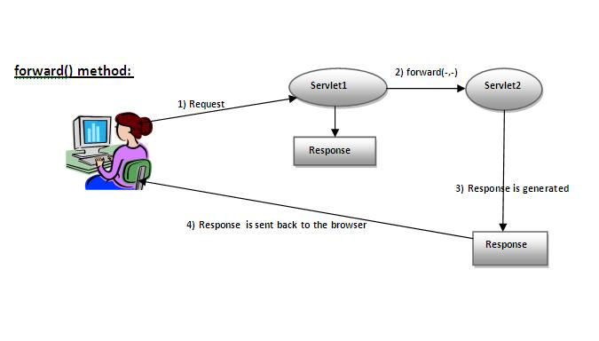

**As you see in the above figure, response of second servlet is sent to the client. Response of the first servlet is not displayed to the user.**

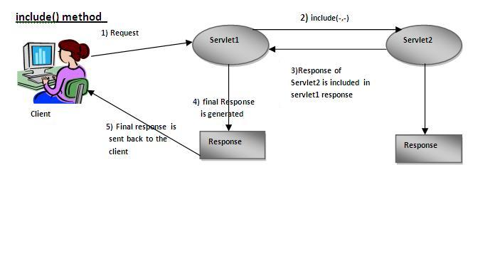

|  |
| --- |
| **As you can see in the above figure, response of second servlet is included in the response of the first servlet that is being sent to the client.** |

### How to get the object of RequestDispatcher

**The getRequestDispatcher() method of ServletRequest interface returns the object of RequestDispatcher. Syntax:**

#### Syntax of getRequestDispatcher method

1. **public RequestDispatcher getRequestDispatcher(String resource);**

#### Example of using getRequestDispatcher method

1. **RequestDispatcher rd=request.getRequestDispatcher("servlet2");**
2. **//servlet2 is the url-pattern of the second servlet**
4. **rd.forward(request, response);//method may be include or forward**

### Example of RequestDispatcher interface

**In this example, we are validating the password entered by the user. If password is servlet, it will forward the request to the WelcomeServlet, otherwise will show an error message: sorry username or password error!. In this program, we are cheking for hardcoded information. But you can check it to the database also that we will see in the development chapter. In this example, we have created following files:**

* **index.html file: for getting input from the user.**
* **Login.java file: a servlet class for processing the response. If password is servet, it will forward the request to the welcome servlet.**
* **WelcomeServlet.java file: a servlet class for displaying the welcome message.**
* **web.xml file: a deployment descriptor file that contains the information about the servlet.**

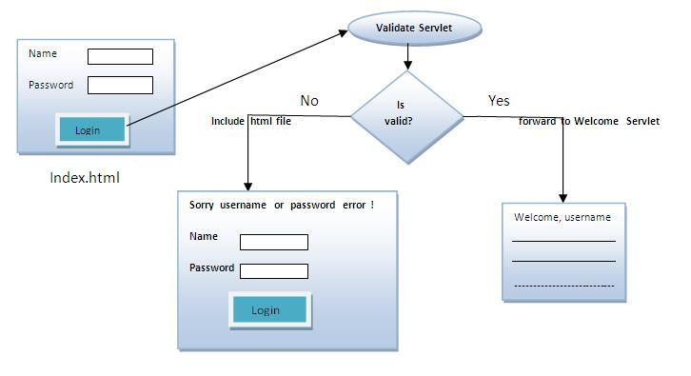

**index.html**

1. **<form action="servlet1" method="post">**
2. **Name:<input type="text" name="userName"/><br/>**
3. **Password:<input type="password" name="userPass"/><br/>**
4. **<input type="submit" value="login"/>**
5. **</form>**

**Login.java**

1. **import java.io.*;**
2. **import javax.servlet.*;**
3. **import javax.servlet.http.*;**

6. **public class Login extends HttpServlet {**
8. **public void doPost(HttpServletRequest request, HttpServletResponse response)**
9. **throws ServletException, IOException {**
11. **response.setContentType("text/html");**
12. **PrintWriter out = response.getWriter();**
14. **String n=request.getParameter("userName");**
15. **String p=request.getParameter("userPass");**
17. **if(p.equals("servlet"){**
18. **RequestDispatcher rd=request.getRequestDispatcher("servlet2");**
19. **rd.forward(request, response);**
20. **}**
21. **else{**
22. **out.print("Sorry UserName or Password Error!");**
23. **RequestDispatcher rd=request.getRequestDispatcher("/index.html");**
24. **rd.include(request, response);**
26. **}**
27. **}**
29. **}**

**WelcomeServlet.java**

1. **import java.io.*;**
2. **import javax.servlet.*;**
3. **import javax.servlet.http.*;**
5. **public class WelcomeServlet extends HttpServlet {**
7. **public void doPost(HttpServletRequest request, HttpServletResponse response)**
8. **throws ServletException, IOException {**
10. **response.setContentType("text/html");**
11. **PrintWriter out = response.getWriter();**
13. **String n=request.getParameter("userName");**
14. **out.print("Welcome "+n);**
15. **}**
17. **}**

**web.xml**

1. **<web-app>**
2. **<servlet>**
3. **<servlet-name>Login</servlet-name>**
4. **<servlet-class>Login</servlet-class>**
5. **</servlet>**
6. **<servlet>**
7. **<servlet-name>WelcomeServlet</servlet-name>**
8. **<servlet-class>WelcomeServlet</servlet-class>**
9. **</servlet>**

12. **<servlet-mapping>**
13. **<servlet-name>Login</servlet-name>**
14. **<url-pattern>/servlet1</url-pattern>**
15. **</servlet-mapping>**
16. **<servlet-mapping>**
17. **<servlet-name>WelcomeServlet</servlet-name>**
18. **<url-pattern>/servlet2</url-pattern>**
19. **</servlet-mapping>**
21. **<welcome-file-list>**
22. **<welcome-file>index.html</welcome-file>**
23. **</welcome-file-list>**
24. **</web-app>**

**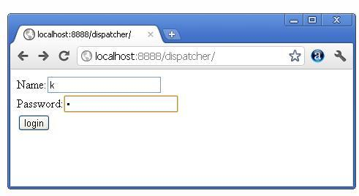 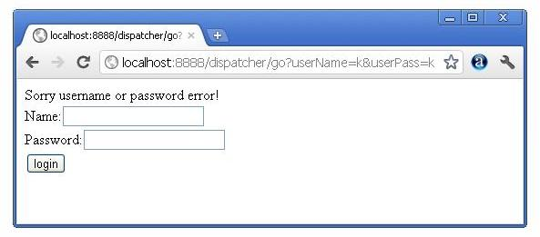 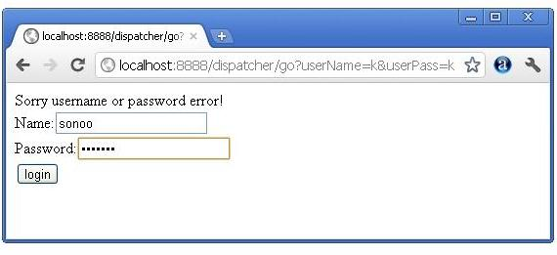 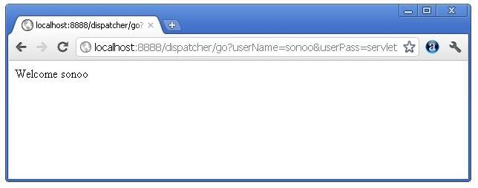**

# SendRedirect in servlet

**The sendRedirect() method of HttpServletResponse interface can be used to redirect response to another resource, it may be servlet, jsp or html file.**

**It accepts relative as well as absolute URL.**

**It works at client side because ituses the url bar of the browser to make another request. So, it can work inside and outside the server.**

## Difference between forward() and sendRedirect() method

**There are many differences between the forward() method of RequestDispatcher and sendRedirect()method of HttpServletResponse interface. They are given below:**

|  |  |
| --- | --- |
| **forward() method** | **sendRedirect() method** |
| **The forward() method works at server side.** | **The sendRedirect() method works at client side.** |
| **It sends the same request and response objects to another servlet.** | **It always sends a new request.** |
| **It can work within the server only.** | **It can be used within and outside the server.** |
| **Example: request.getRequestDispacher("servlet2").forward(request,response);** | **Example: response.sendRedirect("servlet2");** |

### Syntax of sendRedirect() method

1. **public void sendRedirect(String URL)throws IOException;**

### Example of sendRedirect() method

1. **response.sendRedirect("http://www.javatpoint.com");**

### Full example of sendRedirect method in servlet

|  |
| --- |
| **In this example, we are redirecting the request to the google server. Notice that sendRedirect method works at client side, that is why we can our request to anywhere. We can send our request within and outside the server.** |

***DemoServlet.java***

1. **import java.io.*;**
2. **import javax.servlet.*;**
3. **import javax.servlet.http.*;**
5. **public class DemoServlet extends HttpServlet{**
6. **public void doGet(HttpServletRequest req,HttpServletResponse res)**
7. **throws ServletException,IOException**
8. **{**
9. **res.setContentType("text/html");**
10. **PrintWriter pw=res.getWriter();**
12. **response.sendRedirect("http://www.google.com");**
14. **pw.close();**
15. **}}**

### Creating custom google search using sendRedirect

**In this example, we are using sendRedirect method to send request to google server with the request data.**

***index.html***

1. **<!DOCTYPE html>**
2. **<html>**
3. **<head>**
4. **<meta charset="ISO-8859-1">**
5. **<title>sendRedirect example</title>**
6. **</head>**
7. **<body>**

10. **<form action="MySearcher">**
11. **<input type="text" name="name">**
12. **<input type="submit" value="Google Search">**
13. **</form>**
15. **</body>**
16. **</html>**

***MySearcher.java***

1. **import java.io.IOException;**
2. **import javax.servlet.ServletException;**
3. **import javax.servlet.http.HttpServlet;**
4. **import javax.servlet.http.HttpServletRequest;**
5. **import javax.servlet.http.HttpServletResponse;**
7. **public class MySearcher extends HttpServlet {**
8. **protected void doGet(HttpServletRequest request, HttpServletResponse response)**
9. **throws ServletException, IOException {**
11. **String name=request.getParameter("name");**
12. **response.sendRedirect("https://www.google.co.in/#q="+name);**
13. **}**
14. **}**

#### Output

**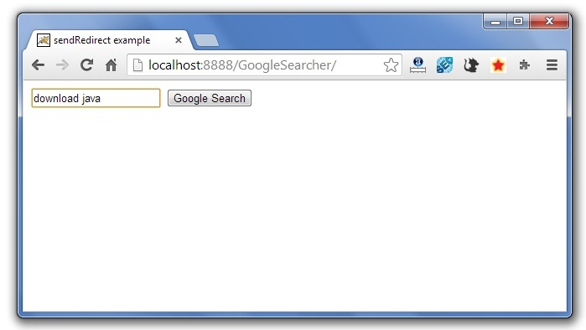  
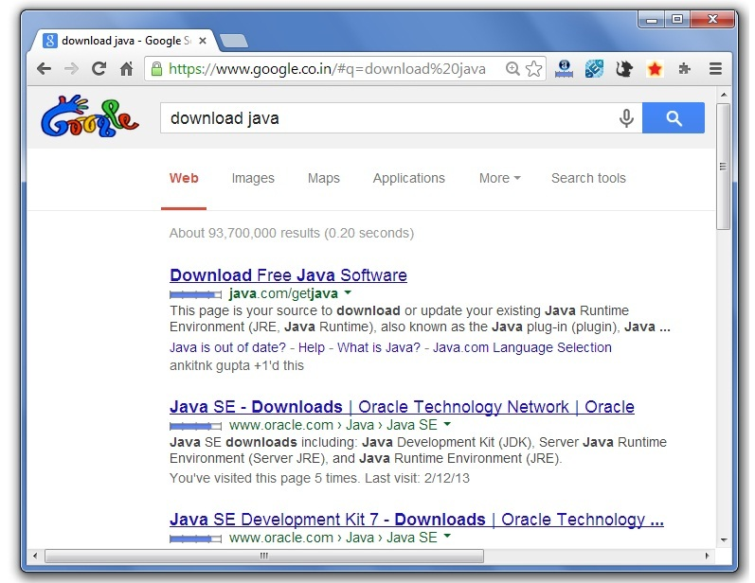**

# ServletConfig Interface

**An object of ServletConfig is created by the web container for each servlet. This object can be used to get configuration information from web.xml file.**

**If the configuration information is modified from the web.xml file, we don't need to change the servlet. So it is easier to manage the web application if any specific content is modified from time to time.**

### Advantage of ServletConfig

**The core advantage of ServletConfig is that you don't need to edit the servlet file if information is modified from the web.xml file.**

### Methods of ServletConfig interface

1. **public String getInitParameter(String name):Returns the parameter value for the specified parameter name.**
2. **public Enumeration getInitParameterNames():Returns an enumeration of all the initialization parameter names.**
3. **public String getServletName():Returns the name of the servlet.**
4. **public ServletContext getServletContext():Returns an object of ServletContext.**

### How to get the object of ServletConfig

1. **getServletConfig() method of Servlet interface returns the object of ServletConfig.**

#### Syntax of getServletConfig() method

1. **public ServletConfig getServletConfig();**

### Example of getServletConfig() method

1. **ServletConfig config=getServletConfig();**
2. **//Now we can call the methods of ServletConfig interface**

### Syntax to provide the initialization parameter for a servlet

**The init-param sub-element of servlet is used to specify the initialization parameter for a servlet.**

1. **<web-app>**
2. **<servlet>**
3. **......**
5. **<init-param>**
6. **<param-name>parametername</param-name>**
7. **<param-value>parametervalue</param-value>**
8. **</init-param>**
9. **......**
10. **</servlet>**
11. **</web-app>**

### Example of ServletConfig to get initialization parameter

**In this example, we are getting the one initialization parameter from the web.xml file and printing this information in the servlet.**

**DemoServlet.java**

1. **import java.io.*;**
2. **import javax.servlet.*;**
3. **import javax.servlet.http.*;**
5. **public class DemoServlet extends HttpServlet {**
6. **public void doGet(HttpServletRequest request, HttpServletResponse response)**
7. **throws ServletException, IOException {**
9. **response.setContentType("text/html");**
10. **PrintWriter out = response.getWriter();**
12. **ServletConfig config=getServletConfig();**
13. **String driver=config.getInitParameter("driver");**
14. **out.print("Driver is: "+driver);**
16. **out.close();**
17. **}**
19. **}**

**web.xml**

1. **<web-app>**
3. **<servlet>**
4. **<servlet-name>DemoServlet</servlet-name>**
5. **<servlet-class>DemoServlet</servlet-class>**
7. **<init-param>**
8. **<param-name>driver</param-name>**
9. **<param-value>sun.jdbc.odbc.JdbcOdbcDriver</param-value>**
10. **</init-param>**
12. **</servlet>**
14. **<servlet-mapping>**
15. **<servlet-name>DemoServlet</servlet-name>**
16. **<url-pattern>/servlet1</url-pattern>**
17. **</servlet-mapping>**
19. **</web-app>**

### Example of ServletConfig to get all the initialization parameters

**In this example, we are getting all the initialization parameter from the web.xml file and printing this information in the servlet.**

**DemoServlet.java**

1. **import java.io.IOException;**
2. **import java.io.PrintWriter;**
3. **import java.util.Enumeration;**
5. **import javax.servlet.ServletConfig;**
6. **import javax.servlet.ServletException;**
7. **import javax.servlet.http.HttpServlet;**
8. **import javax.servlet.http.HttpServletRequest;**
9. **import javax.servlet.http.HttpServletResponse;**

12. **public class DemoServlet extends HttpServlet {**
13. **public void doGet(HttpServletRequest request, HttpServletResponse response)**
14. **throws ServletException, IOException {**
16. **response.setContentType("text/html");**
17. **PrintWriter out = response.getWriter();**
19. **ServletConfig config=getServletConfig();**
20. **Enumeration<String> e=config.getInitParameterNames();**
22. **String str="";**
23. **while(e.hasMoreElements()){**
24. **str=e.nextElement();**
25. **out.print("<br>Name: "+str);**
26. **out.print(" value: "+config.getInitParameter(str));**
27. **}**
29. **out.close();**
30. **}**
32. **}**

**web.xml**

1. **<web-app>**
3. **<servlet>**
4. **<servlet-name>DemoServlet</servlet-name>**
5. **<servlet-class>DemoServlet</servlet-class>**
7. **<init-param>**
8. **<param-name>username</param-name>**
9. **<param-value>system</param-value>**
10. **</init-param>**
12. **<init-param>**
13. **<param-name>password</param-name>**
14. **<param-value>oracle</param-value>**
15. **</init-param>**
17. **</servlet>**
19. **<servlet-mapping>**
20. **<servlet-name>DemoServlet</servlet-name>**
21. **<url-pattern>/servlet1</url-pattern>**
22. **</servlet-mapping>**
24. **</web-app>**

# ServletContext Interface

**An object of ServletContext is created by the web container at time of deploying the project. This object can be used to get configuration information from web.xml file. There is only one ServletContext object per web application.**

**If any information is shared to many servlet, it is better to provide it from the web.xml file using the <context-param> element.**

### Advantage of ServletContext

**Easy to maintain if any information is shared to all the servlet, it is better to make it available for all the servlet. We provide this information from the web.xml file, so if the information is changed, we don't need to modify the servlet. Thus it removes maintenance problem.**

### Usage of ServletContext Interface

**There can be a lot of usage of ServletContext object. Some of them are as follows:**

1. **The object of ServletContext provides an interface between the container and servlet.**
2. **The ServletContext object can be used to get configuration information from the web.xml file.**
3. **The ServletContext object can be used to set, get or remove attribute from the web.xml file.**
4. **The ServletContext object can be used to provide inter-application communication.**

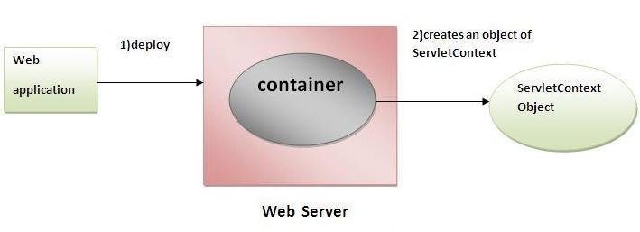

### Commonly used methods of ServletContext interface

|  |
| --- |
| **There is given some commonly used methods of ServletContext interface.**   1. **public String getInitParameter(String name):Returns the parameter value for the specified parameter name.** 2. **public Enumeration getInitParameterNames():Returns the names of the context's initialization parameters.** 3. **public void setAttribute(String name,Object object):sets the given object in the application scope.** 4. **public Object getAttribute(String name):Returns the attribute for the specified name.** 5. **public Enumeration getInitParameterNames():Returns the names of the context's initialization parameters as an Enumeration of String objects.** 6. **public void removeAttribute(String name):Removes the attribute with the given name from the servlet context.** |

### How to get the object of ServletContext interface

1. **getServletContext() method of ServletConfig interface returns the object of ServletContext.**
2. **getServletContext() method of GenericServlet class returns the object of ServletContext.**

#### Syntax of getServletContext() method

1. **public ServletContext getServletContext()**

#### Example of getServletContext() method

1. **//We can get the ServletContext object from ServletConfig object**
2. **ServletContext application=getServletConfig().getServletContext();**
4. **//Another convenient way to get the ServletContext object**
5. **ServletContext application=getServletContext();**

### Syntax to provide the initialization parameter in Context scope

|  |
| --- |
| **The context-param element, subelement of web-app, is used to define the initialization parameterin the application scope. The param-name and param-value are the sub-elements of the context-param. The param-name element defines parameter name and and param-value defines its value.** |

1. **<web-app>**
2. **......**
4. **<context-param>**
5. **<param-name>parametername</param-name>**
6. **<param-value>parametervalue</param-value>**
7. **</context-param>**
8. **......**
9. **</web-app>**

### Example of ServletContext to get the initialization parameter

|  |
| --- |
| **In this example, we are getting the initialization parameter from the web.xml file and printing the value of the initialization parameter. Notice that the object of ServletContext represents the application scope. So if we change the value of the parameter from the web.xml file, all the servlet classes will get the changed value. So we don't need to modify the servlet. So it is better to have the common information for most of the servlets in the web.xml file by context-param element. Let's see the simple example:** |

**DemoServlet.java**

1. **import java.io.*;**
2. **import javax.servlet.*;**
3. **import javax.servlet.http.*;**

6. **public class DemoServlet extends HttpServlet{**
7. **public void doGet(HttpServletRequest req,HttpServletResponse res)**
8. **throws ServletException,IOException**
9. **{**
10. **res.setContentType("text/html");**
11. **PrintWriter pw=res.getWriter();**
13. **//creating ServletContext object**
14. **ServletContext context=getServletContext();**
16. **//Getting the value of the initialization parameter and printing it**
17. **String driverName=context.getInitParameter("dname");**
18. **pw.println("driver name is="+driverName);**
20. **pw.close();**
22. **}}**

**web.xml**

1. **<web-app>**
3. **<servlet>**
4. **<servlet-name>sonoojaiswal</servlet-name>**
5. **<servlet-class>DemoServlet</servlet-class>**
6. **</servlet>**
8. **<context-param>**
9. **<param-name>dname</param-name>**
10. **<param-value>sun.jdbc.odbc.JdbcOdbcDriver</param-value>**
11. **</context-param>**
13. **<servlet-mapping>**
14. **<servlet-name>sonoojaiswal</servlet-name>**
15. **<url-pattern>/context</url-pattern>**
16. **</servlet-mapping>**
18. **</web-app>**

### Example of ServletContext to get all the initialization parameters

|  |
| --- |
| **In this example, we are getting all the initialization parameter from the web.xml file. For getting all the parameters, we have used the getInitParameterNames() method in the servlet class.** |

**DemoServlet.java**

1. **import java.io.*;**
2. **import javax.servlet.*;**
3. **import javax.servlet.http.*;**

6. **public class DemoServlet extends HttpServlet{**
7. **public void doGet(HttpServletRequest req,HttpServletResponse res)**
8. **throws ServletException,IOException**
9. **{**
10. **res.setContentType("text/html");**
11. **PrintWriter out=res.getWriter();**
13. **ServletContext context=getServletContext();**
14. **Enumeration<String> e=context.getInitParameterNames();**
16. **String str="";**
17. **while(e.hasMoreElements()){**
18. **str=e.nextElement();**
19. **out.print("<br> "+context.getInitParameter(str));**
20. **}**
21. **}}**

**web.xml**

1. **<web-app>**
3. **<servlet>**
4. **<servlet-name>sonoojaiswal</servlet-name>**
5. **<servlet-class>DemoServlet</servlet-class>**
6. **</servlet>**
8. **<context-param>**
9. **<param-name>dname</param-name>**
10. **<param-value>sun.jdbc.odbc.JdbcOdbcDriver</param-value>**
11. **</context-param>**
13. **<context-param>**
14. **<param-name>username</param-name>**
15. **<param-value>system</param-value>**
16. **</context-param>**
18. **<context-param>**
19. **<param-name>password</param-name>**
20. **<param-value>oracle</param-value>**
21. **</context-param>**
23. **<servlet-mapping>**
24. **<servlet-name>sonoojaiswal</servlet-name>**
25. **<url-pattern>/context</url-pattern>**
26. **</servlet-mapping>**
28. **</web-app>**

# Attribute in Servlet

**An attribute in servlet is an object that can be set, get or removed from one of the following scopes:**

1. **request scope**
2. **session scope**
3. **application scope**

**The servlet programmer can pass informations from one servlet to another using attributes. It is just like passing object from one class to another so that we can reuse the same object again and again.**

### Attribute specific methods of ServletRequest, HttpSession and ServletContext interface

|  |
| --- |
| **There are following 4 attribute specific methods. They are as follows:**   1. **public void setAttribute(String name,Object object):sets the given object in the application scope.** 2. **public Object getAttribute(String name):Returns the attribute for the specified name.** 3. **public Enumeration getInitParameterNames():Returns the names of the context's initialization parameters as an Enumeration of String objects.** 4. **public void removeAttribute(String name):Removes the attribute with the given name from the servlet context.** |

### Example of ServletContext to set and get attribute

|  |
| --- |
| **In this example, we are setting the attribute in the application scope and getting that value from another servlet.** |

### DemoServlet1.java

1. **import java.io.*;**
2. **import javax.servlet.*;**
3. **import javax.servlet.http.*;**

6. **public class DemoServlet1 extends HttpServlet{**
7. **public void doGet(HttpServletRequest req,HttpServletResponse res)**
8. **{**
9. **try{**
11. **res.setContentType("text/html");**
12. **PrintWriter out=res.getWriter();**
14. **ServletContext context=getServletContext();**
15. **context.setAttribute("company","IBM");**
17. **out.println("Welcome to first servlet");**
18. **out.println("<a href='servlet2'>visit</a>");**
19. **out.close();**
21. **}catch(Exception e){out.println(e);}**
23. **}}**

### DemoServlet2.java

1. **import java.io.*;**
2. **import javax.servlet.*;**
3. **import javax.servlet.http.*;**

6. **public class DemoServlet2 extends HttpServlet{**
7. **public void doGet(HttpServletRequest req,HttpServletResponse res)**
8. **{**
9. **try{**
11. **res.setContentType("text/html");**
12. **PrintWriter out=res.getWriter();**
14. **ServletContext context=getServletContext();**
15. **String n=(String)context.getAttribute("company");**
17. **out.println("Welcome to "+n);**
18. **out.close();**
20. **}catch(Exception e){out.println(e);}**
22. **}}**

### web.xml

1. **<web-app>**
3. **<servlet>**
4. **<servlet-name>s1</servlet-name>**
5. **<servlet-class>DemoServlet1</servlet-class>**
6. **</servlet>**
8. **<servlet-mapping>**
9. **<servlet-name>s1</servlet-name>**
10. **<url-pattern>/servlet1</url-pattern>**
11. **</servlet-mapping>**
13. **<servlet>**
14. **<servlet-name>s2</servlet-name>**
15. **<servlet-class>DemoServlet2</servlet-class>**
16. **</servlet>**
18. **<servlet-mapping>**
19. **<servlet-name>s2</servlet-name>**
20. **<url-pattern>/servlet2</url-pattern>**
21. **</servlet-mapping>**
23. **</web-app>**

### Difference between ServletConfig and ServletContext

|  |
| --- |
| **The servletconfig object refers to the single servlet whereas servletcontext object refers to the whole web application.** |

# Session Tracking in Servlets

**Session simply means a particular interval of time.**

**Session Tracking is a way to maintain state (data) of an user. It is also known as session management in servlet.**

**Http protocol is a stateless so we need to maintain state using session tracking techniques. Each time user requests to the server, server treats the request as the new request. So we need to maintain the state of an user to recognize to particular user.**

**HTTP is stateless that means each request is considered as the new request. It is shown in the figure given below:**

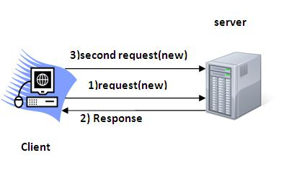

### Why use Session Tracking?

**To recognize the user It is used to recognize the particular user.**

### Session Tracking Techniques

**There are four techniques used in Session tracking:**

1. **Cookies**
2. **Hidden Form Field**
3. **URL Rewriting**
4. **HttpSession**

# Cookies in Servlet

**A cookie is a small piece of information that is persisted between the multiple client requests.**

**A cookie has a name, a single value, and optional attributes such as a comment, path and domain qualifiers, a maximum age, and a version number.**

### How Cookie works

**By default, each request is considered as a new request. In cookies technique, we add cookie with response from the servlet. So cookie is stored in the cache of the browser. After that if request is sentby the user, cookie is added with request by default. Thus, we recognize the user as the old user.**

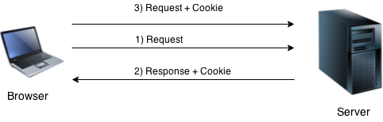

### Types of Cookie

**There are 2 types of cookies in servlets.**

1. **Non-persistent cookie**
2. **Persistent cookie**

### Non-persistent cookie

**It is valid for single session only.It is removed each time when user closes the browser.**

### Persistent cookie

**It is valid for multiple session . It is not removed each time when user closes the browser. It is removed only if user logout or signout.**

### Advantage of Cookies

1. **Simplest technique of maintaining the state.**
2. **Cookies are maintained at client side.**

### Disadvantage of Cookies

1. **It will not work if cookie is disabled from the browser.**
2. **Only textual information can be set in Cookie object.**

#### Note: Gmail uses cookie technique for login. If you disable the cookie, gmail won't work.

### Cookie class

**javax.servlet.http.Cookie class provides the functionality of using cookies. It provides a lot of useful methods for cookies.**

### Constructor of Cookie class

|  |  |
| --- | --- |
| **Constructor** | **Description** |
| **Cookie()** | **constructs a cookie.** |
| **Cookie(String name, String value)** | **constructs a cookie with a specified name and value.** |

### Useful Methods of Cookie class

**There are given some commonly used methods of the Cookie class.**

|  |  |
| --- | --- |
| **Method** | **Description** |
| **public void setMaxAge(int expiry)** | **Sets the maximum age of the cookie in seconds.** |
| **public String getName()** | **Returns the name of the cookie. The name cannot be changed after creation.** |
| **public String getValue()** | **Returns the value of the cookie.** |
| **public void setName(String name)** | **changes the name of the cookie.** |
| **public void setValue(String value)** | **changes the value of the cookie.** |

### Other methods required for using Cookies

|  |
| --- |
| **For adding cookie or getting the value from the cookie, we need some methods provided by other interfaces. They are:**   1. **public void addCookie(Cookie ck):method of HttpServletResponse interface is used to add cookie in response object.** 2. **public Cookie[] getCookies():method of HttpServletRequest interface is used to return all the cookies from the browser.** |

### How to create Cookie?

**Let's see the simple code to create cookie.**

1. **Cookie ck=new Cookie("user","sonoo jaiswal");//creating cookie object**
2. **response.addCookie(ck);//adding cookie in the response**

### How to delete Cookie?

**Let's see the simple code to delete cookie. It is mainly used to logout or signout the user.**

1. **Cookie ck=new Cookie("user","");//deleting value of cookie**
2. **ck.setMaxAge(0);//changing the maximum age to 0 seconds**
3. **response.addCookie(ck);//adding cookie in the response**

### How to get Cookies?

**Let's see the simple code to get all the cookies.**

1. **Cookie ck[]=request.getCookies();**
2. **for(int i=0;i<ck.length;i++){**
3. **out.print("<br>"+ck[i].getName()+" "+ck[i].getValue());//printing name and value of cookie**
4. **}**

### Simple example of Servlet Cookies

**In this example, we are storing the name of the user in the cookie object and accessing it in another servlet. As we know well that session corresponds to the particular user. So if you access it from too many browsers with different values, you will get the different value.**

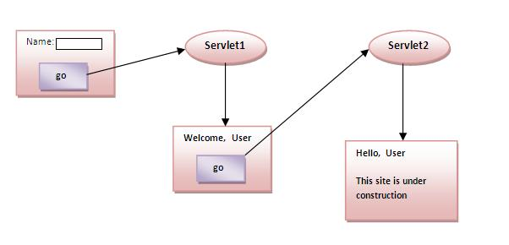

### index.html

1. **<form action="servlet1" method="post">**
2. **Name:<input type="text" name="userName"/><br/>**
3. **<input type="submit" value="go"/>**
4. **</form>**

### FirstServlet.java

1. **import java.io.*;**
2. **import javax.servlet.*;**
3. **import javax.servlet.http.*;**

6. **public class FirstServlet extends HttpServlet {**
8. **public void doPost(HttpServletRequest request, HttpServletResponse response){**
9. **try{**
11. **response.setContentType("text/html");**
12. **PrintWriter out = response.getWriter();**
14. **String n=request.getParameter("userName");**
15. **out.print("Welcome "+n);**
17. **Cookie ck=new Cookie("uname",n);//creating cookie object**
18. **response.addCookie(ck);//adding cookie in the response**
20. **//creating submit button**
21. **out.print("<form action='servlet2'>");**
22. **out.print("<input type='submit' value='go'>");**
23. **out.print("</form>");**
25. **out.close();**
27. **}catch(Exception e){System.out.println(e);}**
28. **}**
29. **}**

### SecondServlet.java

1. **import java.io.*;**
2. **import javax.servlet.*;**
3. **import javax.servlet.http.*;**
5. **public class SecondServlet extends HttpServlet {**
7. **public void doPost(HttpServletRequest request, HttpServletResponse response){**
8. **try{**
10. **response.setContentType("text/html");**
11. **PrintWriter out = response.getWriter();**
13. **Cookie ck[]=request.getCookies();**
14. **out.print("Hello "+ck[0].getValue());**
16. **out.close();**
18. **}catch(Exception e){System.out.println(e);}**
19. **}**

22. **}**

### web.xml

1. **<web-app>**
3. **<servlet>**
4. **<servlet-name>s1</servlet-name>**
5. **<servlet-class>FirstServlet</servlet-class>**
6. **</servlet>**
8. **<servlet-mapping>**
9. **<servlet-name>s1</servlet-name>**
10. **<url-pattern>/servlet1</url-pattern>**
11. **</servlet-mapping>**
13. **<servlet>**
14. **<servlet-name>s2</servlet-name>**
15. **<servlet-class>SecondServlet</servlet-class>**
16. **</servlet>**
18. **<servlet-mapping>**
19. **<servlet-name>s2</servlet-name>**
20. **<url-pattern>/servlet2</url-pattern>**
21. **</servlet-mapping>**
23. **</web-app>**

#### Output

**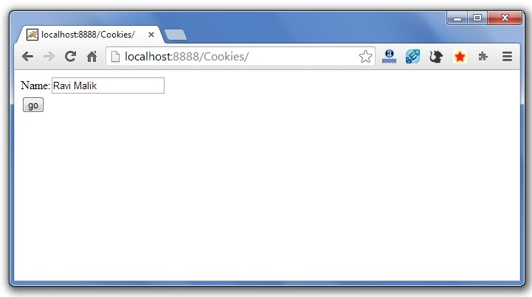 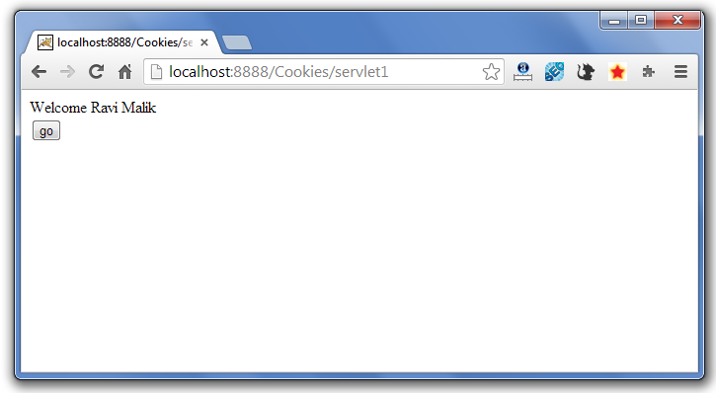 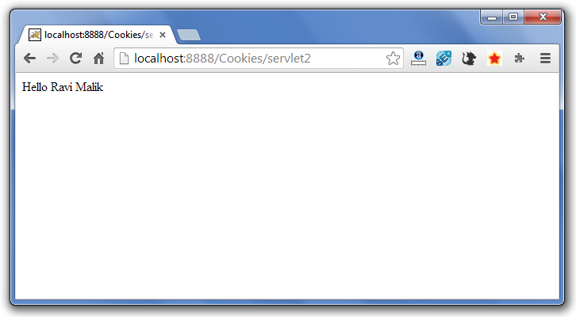**

**Servlet Login and Logout Example using Cookies**

**A cookie is a kind of information that is stored at client side.**

**In the previous page, we learned a lot about cookie e.g. how to create cookie, how to delete cookie, how to get cookie etc.**

**Here, we are going to create a login and logout example using servlet cookies.**

**In this example, we are creating 3 links: login, logout and profile. User can't go to profile page until he/she is logged in. If user is logged out, he need to login again to visit profile.**

**In this application, we have created following files.**

1. **index.html**
2. **link.html**
3. **login.html**
4. **LoginServlet.java**
5. **LogoutServlet.java**
6. **ProfileServlet.java**
7. **web.xml**

***File: index.html***

1. **<!DOCTYPE html>**
2. **<html>**
3. **<head>**
4. **<meta charset="ISO-8859-1">**
5. **<title>Servlet Login Example</title>**
6. **</head>**
7. **<body>**
9. **<h1>Welcome to Login App by Cookie</h1>**
10. **<a href="login.html">Login</a>|**
11. **<a href="LogoutServlet">Logout</a>|**
12. **<a href="ProfileServlet">Profile</a>**
14. **</body>**
15. **</html>**

***File: link.html***

1. **<a href="login.html">Login</a> |**
2. **<a href="LogoutServlet">Logout</a> |**
3. **<a href="ProfileServlet">Profile</a>**
4. **<hr>**

***File: login.html***

1. **<form action="LoginServlet" method="post">**
2. **Name:<input type="text" name="name"><br>**
3. **Password:<input type="password" name="password"><br>**
4. **<input type="submit" value="login">**
5. **</form>**

***File: LoginServlet.java***

1. **package com.javatpoint;**
3. **import java.io.IOException;**
4. **import java.io.PrintWriter;**
5. **import javax.servlet.ServletException;**
6. **import javax.servlet.http.Cookie;**
7. **import javax.servlet.http.HttpServlet;**
8. **import javax.servlet.http.HttpServletRequest;**
9. **import javax.servlet.http.HttpServletResponse;**
10. **public class LoginServlet extends HttpServlet {**
11. **protected void doPost(HttpServletRequest request, HttpServletResponse response)**
12. **throws ServletException, IOException {**
13. **response.setContentType("text/html");**
14. **PrintWriter out=response.getWriter();**
16. **request.getRequestDispatcher("link.html").include(request, response);**
18. **String name=request.getParameter("name");**
19. **String password=request.getParameter("password");**
21. **if(password.equals("admin123")){**
22. **out.print("You are successfully logged in!");**
23. **out.print("<br>Welcome, "+name);**
25. **Cookie ck=new Cookie("name",name);**
26. **response.addCookie(ck);**
27. **}else{**
28. **out.print("sorry, username or password error!");**
29. **request.getRequestDispatcher("login.html").include(request, response);**
30. **}**
32. **out.close();**
33. **}**
35. **}**

***File: LogoutServlet.java***

1. **package com.javatpoint;**
3. **import java.io.IOException;**
4. **import java.io.PrintWriter;**
5. **import javax.servlet.ServletException;**
6. **import javax.servlet.http.Cookie;**
7. **import javax.servlet.http.HttpServlet;**
8. **import javax.servlet.http.HttpServletRequest;**
9. **import javax.servlet.http.HttpServletResponse;**
10. **public class LogoutServlet extends HttpServlet {**
11. **protected void doGet(HttpServletRequest request, HttpServletResponse response)**
12. **throws ServletException, IOException {**
13. **response.setContentType("text/html");**
14. **PrintWriter out=response.getWriter();**

17. **request.getRequestDispatcher("link.html").include(request, response);**
19. **Cookie ck=new Cookie("name","");**
20. **ck.setMaxAge(0);**
21. **response.addCookie(ck);**
23. **out.print("you are successfully logged out!");**
24. **}**
25. **}**

***File: ProfileServlet.java***

1. **package com.javatpoint;**
3. **import java.io.IOException;**
4. **import java.io.PrintWriter;**
5. **import javax.servlet.ServletException;**
6. **import javax.servlet.http.Cookie;**
7. **import javax.servlet.http.HttpServlet;**
8. **import javax.servlet.http.HttpServletRequest;**
9. **import javax.servlet.http.HttpServletResponse;**
10. **public class ProfileServlet extends HttpServlet {**
11. **protected void doGet(HttpServletRequest request, HttpServletResponse response)**
12. **throws ServletException, IOException {**
13. **response.setContentType("text/html");**
14. **PrintWriter out=response.getWriter();**
16. **request.getRequestDispatcher("link.html").include(request, response);**
18. **Cookie ck[]=request.getCookies();**
19. **if(ck!=null){**
20. **String name=ck[0].getValue();**
21. **if(!name.equals("")||name!=null){**
22. **out.print("<b>Welcome to Profile</b>");**
23. **out.print("<br>Welcome, "+name);**
24. **}**
25. **}else{**
26. **out.print("Please login first");**
27. **request.getRequestDispatcher("login.html").include(request, response);**
28. **}**
29. **out.close();**
30. **}**
31. **}**

***File: web.xml***

1. **<?xml version="1.0" encoding="UTF-8"?>**
2. **<web-app xmlns:xsi="http://www.w3.org/2001/XMLSchema-instance"**
3. **xmlns="http://java.sun.com/xml/ns/javaee" xsi:schemaLocation="http://java.sun.com/xml/ns/javaee**
4. **http://java.sun.com/xml/ns/javaee/web-app_2_5.xsd" id="WebApp_ID" version="2.5">**
6. **<servlet>**
7. **<description></description>**
8. **<display-name>LoginServlet</display-name>**
9. **<servlet-name>LoginServlet</servlet-name>**
10. **<servlet-class>com.javatpoint.LoginServlet</servlet-class>**
11. **</servlet>**
12. **<servlet-mapping>**
13. **<servlet-name>LoginServlet</servlet-name>**
14. **<url-pattern>/LoginServlet</url-pattern>**
15. **</servlet-mapping>**
16. **<servlet>**
17. **<description></description>**
18. **<display-name>ProfileServlet</display-name>**
19. **<servlet-name>ProfileServlet</servlet-name>**
20. **<servlet-class>com.javatpoint.ProfileServlet</servlet-class>**
21. **</servlet>**
22. **<servlet-mapping>**
23. **<servlet-name>ProfileServlet</servlet-name>**
24. **<url-pattern>/ProfileServlet</url-pattern>**
25. **</servlet-mapping>**
26. **<servlet>**
27. **<description></description>**
28. **<display-name>LogoutServlet</display-name>**
29. **<servlet-name>LogoutServlet</servlet-name>**
30. **<servlet-class>com.javatpoint.LogoutServlet</servlet-class>**
31. **</servlet>**
32. **<servlet-mapping>**
33. **<servlet-name>LogoutServlet</servlet-name>**
34. **<url-pattern>/LogoutServlet</url-pattern>**
35. **</servlet-mapping>**
36. **</web-app>**

[**download this example (developed using Eclipse IDE)**](http://www.javatpoint.com/src/servlet/eclipse/loginappcookie.zip)

#### Output

**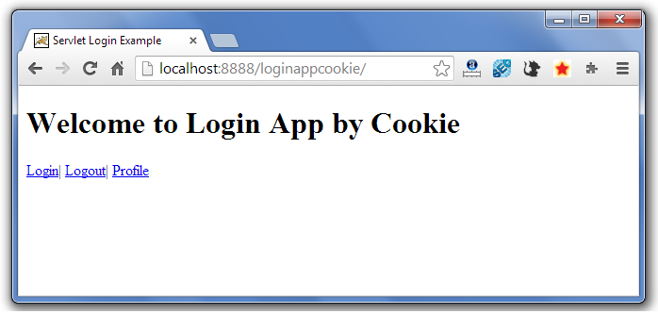 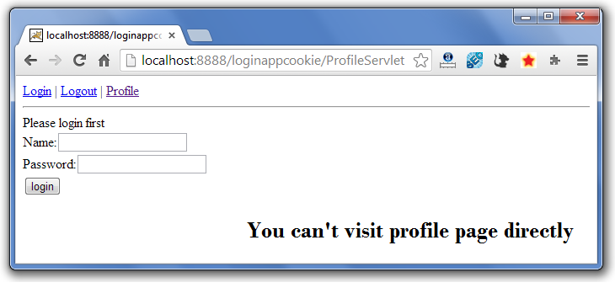 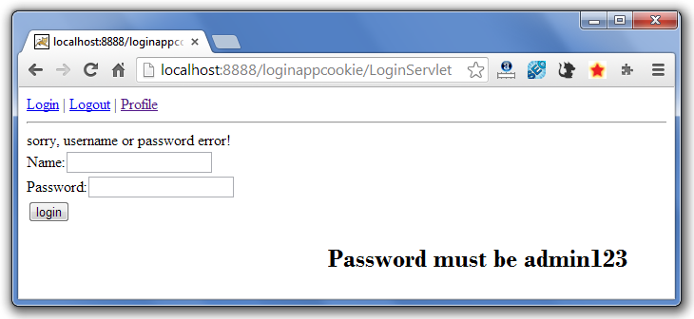 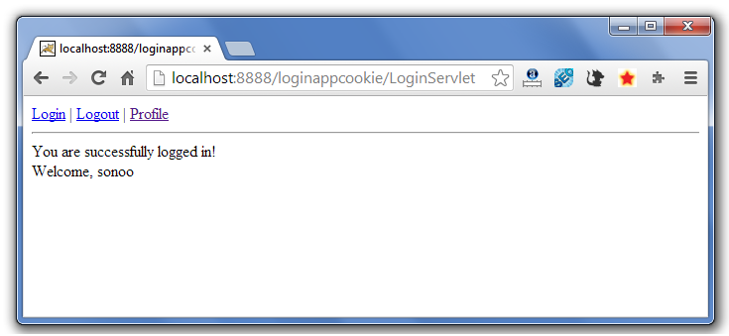**

**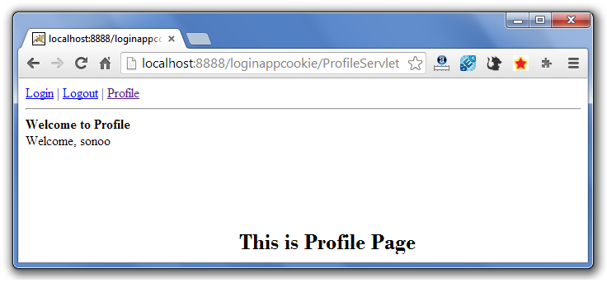 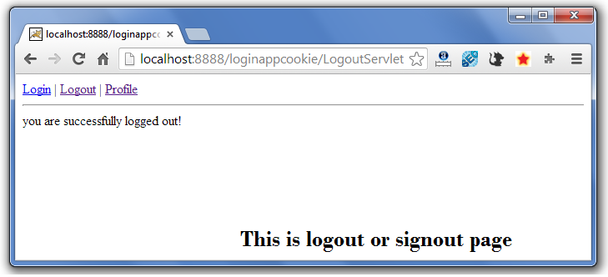**

**If again you click on the profile link, you need to login first.**

# 2) Hidden Form Field

**In case of Hidden Form Field ahidden (invisible) textfield is used for maintaining the state of an user.**

**In such case, we store the information in the hidden field and get it from another servlet. This approach is better if we have to submit form in all the pages and we don't want to depend on the browser.**

**Let's see the code to store value in hidden field.**

1. **<input type="hidden" name="uname" value="Vimal Jaiswal">**

**Here, uname is the hidden field name and Vimal Jaiswal is the hidden field value.**

### Real application of hidden form field

**It is widely used in comment form of a website. In such case, we store page id or page name in the hidden field so that each page can be uniquely identified.**

### Advantage of Hidden Form Field

1. **It will always work whether cookie is disabled or not.**

### Disadvantage of Hidden Form Field:

1. **It is maintained at server side.**
2. **Extra form submission is required on each pages.**
3. **Only textual information can be used.**

### Example of using Hidden Form Field

**In this example, we are storing the name of the user in a hidden textfield and getting that value from another servlet.**

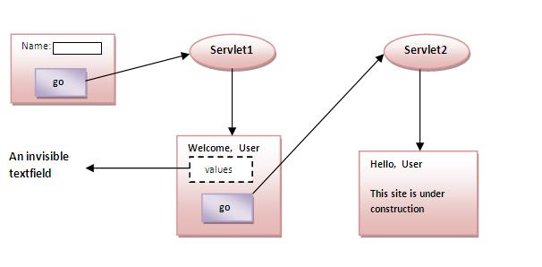

### index.html

1. **<form action="servlet1">**
2. **Name:<input type="text" name="userName"/><br/>**
3. **<input type="submit" value="go"/>**
4. **</form>**

### FirstServlet.java

1. **import java.io.*;**
2. **import javax.servlet.*;**
3. **import javax.servlet.http.*;**
5. **public class FirstServlet extends HttpServlet {**
6. **public void doGet(HttpServletRequest request, HttpServletResponse response){**
7. **try{**
9. **response.setContentType("text/html");**
10. **PrintWriter out = response.getWriter();**
12. **String n=request.getParameter("userName");**
13. **out.print("Welcome "+n);**
15. **//creating form that have invisible textfield**
16. **out.print("<form action='servlet2'>");**
17. **out.print("<input type='hidden' name='uname' value='"+n+"'>");**
18. **out.print("<input type='submit' value='go'>");**
19. **out.print("</form>");**
20. **out.close();**
22. **}catch(Exception e){System.out.println(e);}**
23. **}**
25. **}**

### SecondServlet.java

1. **import java.io.*;**
2. **import javax.servlet.*;**
3. **import javax.servlet.http.*;**
4. **public class SecondServlet extends HttpServlet {**
5. **public void doGet(HttpServletRequest request, HttpServletResponse response)**
6. **try{**
7. **response.setContentType("text/html");**
8. **PrintWriter out = response.getWriter();**
10. **//Getting the value from the hidden field**
11. **String n=request.getParameter("uname");**
12. **out.print("Hello "+n);**
14. **out.close();**
15. **}catch(Exception e){System.out.println(e);}**
16. **}**
17. **}**

### web.xml

1. **<web-app>**
3. **<servlet>**
4. **<servlet-name>s1</servlet-name>**
5. **<servlet-class>FirstServlet</servlet-class>**
6. **</servlet>**
8. **<servlet-mapping>**
9. **<servlet-name>s1</servlet-name>**
10. **<url-pattern>/servlet1</url-pattern>**
11. **</servlet-mapping>**
13. **<servlet>**
14. **<servlet-name>s2</servlet-name>**
15. **<servlet-class>SecondServlet</servlet-class>**
16. **</servlet>**
18. **<servlet-mapping>**
19. **<servlet-name>s2</servlet-name>**
20. **<url-pattern>/servlet2</url-pattern>**
21. **</servlet-mapping>**
23. **</web-app>**

# 3)URL Rewriting

**In URL rewriting, we append a token or identifier to the URL of the next Servlet or the next resource. We can send parameter name/value pairs using the following format:**

**url?name1=value1&name2=value2&??**

**A name and a value is separated using an equal = sign, a parameter name/value pair is separated fromanother parameter using the ampersand(&). When the user clicks the hyperlink, the parametername/value pairs will be passed to the server. From a Servlet, we can use getParameter() method to obtain a parameter value.**

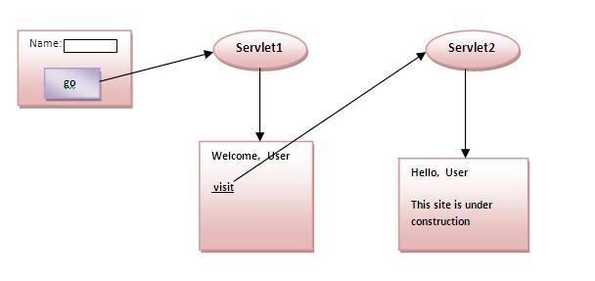

### Advantage of URL Rewriting

1. **It will always work whether cookie is disabled or not (browser independent).**
2. **Extra form submission is not required on each pages.**

### Disadvantage of URL Rewriting

1. **It will work only with links.**
2. **It can send Only textual information.**

### Example of using URL Rewriting

**In this example, we are maintaning the state of the user using link. For this purpose, we are appending the name of the user in the query string and getting the value from the query string in another page.**

### index.html

1. **<form action="servlet1">**
2. **Name:<input type="text" name="userName"/><br/>**
3. **<input type="submit" value="go"/>**
4. **</form>**

### FirstServlet.java

1. **import java.io.*;**
2. **import javax.servlet.*;**
3. **import javax.servlet.http.*;**

6. **public class FirstServlet extends HttpServlet {**
8. **public void doGet(HttpServletRequest request, HttpServletResponse response){**
9. **try{**
11. **response.setContentType("text/html");**
12. **PrintWriter out = response.getWriter();**
14. **String n=request.getParameter("userName");**
15. **out.print("Welcome "+n);**
17. **//appending the username in the query string**
18. **out.print("<a href='servlet2?uname="+n+"'>visit</a>");**
20. **out.close();**
22. **}catch(Exception e){System.out.println(e);}**
23. **}**
25. **}**

### SecondServlet.java

1. **import java.io.*;**
2. **import javax.servlet.*;**
3. **import javax.servlet.http.*;**
5. **public class SecondServlet extends HttpServlet {**
7. **public void doGet(HttpServletRequest request, HttpServletResponse response)**
8. **try{**
10. **response.setContentType("text/html");**
11. **PrintWriter out = response.getWriter();**
13. **//getting value from the query string**
14. **String n=request.getParameter("uname");**
15. **out.print("Hello "+n);**
17. **out.close();**
19. **}catch(Exception e){System.out.println(e);}**
20. **}**

23. **}**

### web.xml

1. **<web-app>**
3. **<servlet>**
4. **<servlet-name>s1</servlet-name>**
5. **<servlet-class>FirstServlet</servlet-class>**
6. **</servlet>**
8. **<servlet-mapping>**
9. **<servlet-name>s1</servlet-name>**
10. **<url-pattern>/servlet1</url-pattern>**
11. **</servlet-mapping>**
13. **<servlet>**
14. **<servlet-name>s2</servlet-name>**
15. **<servlet-class>SecondServlet</servlet-class>**
16. **</servlet>**
18. **<servlet-mapping>**
19. **<servlet-name>s2</servlet-name>**
20. **<url-pattern>/servlet2</url-pattern>**
21. **</servlet-mapping>**
23. **</web-app>**

# 4) HttpSession interface

**In such case, container creates a session id for each user.The container uses this id to identify the particular user.An object of HttpSession can be used to perform two tasks:**

1. **bind objects**
2. **view and manipulate information about a session, such as the session identifier, creation time, and last accessed time.**

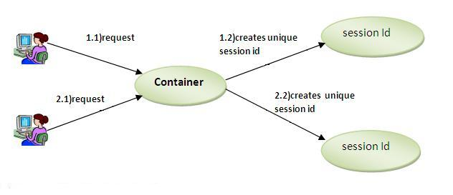

### How to get the HttpSession object ?

**The HttpServletRequest interface provides two methodsto get theobject of HttpSession:**

1. **public HttpSession getSession():Returns the current session associated with this request, or if the request does not have a session, creates one.**
2. **public HttpSession getSession(boolean create):Returns the current HttpSession associated with this request or, if there is no current session and create is true, returns a new session.**

### Commonly used methods of HttpSession interface

1. **public String getId():Returns a string containing the unique identifier value.**
2. **public long getCreationTime():Returns the time when this session was created, measured in milliseconds since midnight January 1, 1970 GMT.**
3. **public long getLastAccessedTime():Returns the last time the client sent a request associated with this session, as the number of milliseconds since midnight January 1, 1970 GMT.**
4. **public void invalidate():Invalidates this session then unbinds any objects bound to it.**

### Example of using HttpSession

**In this example, we are setting the attribute in the session scope in one servlet and getting that value from the session scope in another servlet. To set the attribute in the session scope, we have used the setAttribute() method of HttpSession interface and to get the attribute, we have used the getAttribute method.**

### index.html

1. **<form action="servlet1">**
2. **Name:<input type="text" name="userName"/><br/>**
3. **<input type="submit" value="go"/>**
4. **</form>**

### FirstServlet.java

1. **import java.io.*;**
2. **import javax.servlet.*;**
3. **import javax.servlet.http.*;**

6. **public class FirstServlet extends HttpServlet {**
8. **public void doGet(HttpServletRequest request, HttpServletResponse response){**
9. **try{**
11. **response.setContentType("text/html");**
12. **PrintWriter out = response.getWriter();**
14. **String n=request.getParameter("userName");**
15. **out.print("Welcome "+n);**
17. **HttpSession session=request.getSession();**
18. **session.setAttribute("uname",n);**
20. **out.print("<a href='servlet2'>visit</a>");**
22. **out.close();**
24. **}catch(Exception e){System.out.println(e);}**
25. **}**
27. **}**

### SecondServlet.java

1. **import java.io.*;**
2. **import javax.servlet.*;**
3. **import javax.servlet.http.*;**
5. **public class SecondServlet extends HttpServlet {**
7. **public void doGet(HttpServletRequest request, HttpServletResponse response)**
8. **try{**
10. **response.setContentType("text/html");**
11. **PrintWriter out = response.getWriter();**
13. **HttpSession session=request.getSession(false);**
14. **String n=(String)session.getAttribute("uname");**
15. **out.print("Hello "+n);**
17. **out.close();**
19. **}catch(Exception e){System.out.println(e);}**
20. **}**

23. **}**

### web.xml

1. **<web-app>**
3. **<servlet>**
4. **<servlet-name>s1</servlet-name>**
5. **<servlet-class>FirstServlet</servlet-class>**
6. **</servlet>**
8. **<servlet-mapping>**
9. **<servlet-name>s1</servlet-name>**
10. **<url-pattern>/servlet1</url-pattern>**
11. **</servlet-mapping>**
13. **<servlet>**
14. **<servlet-name>s2</servlet-name>**
15. **<servlet-class>SecondServlet</servlet-class>**
16. **</servlet>**
18. **<servlet-mapping>**
19. **<servlet-name>s2</servlet-name>**
20. **<url-pattern>/servlet2</url-pattern>**
21. **</servlet-mapping>**
23. **</web-app>**

**Servlet HttpSession Login and Logout Example**

**We can bind the objects on HttpSession instance and get the objects by using setAttribute and getAttribute methods.**

**In the previous page, we have learnt about what is HttpSession, How to store and get data from session object etc.**

**Here, we are going to create a real world login and logout application without using database code. We are assuming that password is admin123.**

**Visit here for login and logout application using cookies only**[**servlet login and logout example using cookies**](http://www.javatpoint.com/servlet-login-and-logout-example-using-cookies)

**In this example, we are creating 3 links: login, logout and profile. User can't go to profile page until he/she is logged in. If user is logged out, he need to login again to visit profile.**

**In this application, we have created following files.**

1. **index.html**
2. **link.html**
3. **login.html**
4. **LoginServlet.java**
5. **LogoutServlet.java**
6. **ProfileServlet.java**
7. **web.xml**

***File: index.html***

1. **<!DOCTYPE html>**
2. **<html>**
3. **<head>**
4. **<meta charset="ISO-8859-1">**
5. **<title>Servlet Login Example</title>**
6. **</head>**
7. **<body>**
9. **<h1>Login App using HttpSession</h1>**
10. **<a href="login.html">Login</a>|**
11. **<a href="LogoutServlet">Logout</a>|**
12. **<a href="ProfileServlet">Profile</a>**
14. **</body>**
15. **</html>**

***File: link.html***

1. **<a href="login.html">Login</a> |**
2. **<a href="LogoutServlet">Logout</a> |**
3. **<a href="ProfileServlet">Profile</a>**
4. **<hr>**

***File: login.html***

1. **<form action="LoginServlet" method="post">**
2. **Name:<input type="text" name="name"><br>**
3. **Password:<input type="password" name="password"><br>**
4. **<input type="submit" value="login">**
5. **</form>**

***File: LoginServlet.java***

1. **import java.io.IOException;**
2. **import java.io.PrintWriter;**
4. **import javax.servlet.ServletException;**
5. **import javax.servlet.http.HttpServlet;**
6. **import javax.servlet.http.HttpServletRequest;**
7. **import javax.servlet.http.HttpServletResponse;**
8. **import javax.servlet.http.HttpSession;**
9. **public class LoginServlet extends HttpServlet {**
10. **protected void doPost(HttpServletRequest request, HttpServletResponse response)**
11. **throws ServletException, IOException {**
12. **response.setContentType("text/html");**
13. **PrintWriter out=response.getWriter();**
14. **request.getRequestDispatcher("link.html").include(request, response);**
16. **String name=request.getParameter("name");**
17. **String password=request.getParameter("password");**
19. **if(password.equals("admin123")){**
20. **out.print("Welcome, "+name);**
21. **HttpSession session=request.getSession();**
22. **session.setAttribute("name",name);**
23. **}**
24. **else{**
25. **out.print("Sorry, username or password error!");**
26. **request.getRequestDispatcher("login.html").include(request, response);**
27. **}**
28. **out.close();**
29. **}**
30. **}**

***File: LogoutServlet.java***

1. **import java.io.IOException;**
2. **import java.io.PrintWriter;**
4. **import javax.servlet.ServletException;**
5. **import javax.servlet.http.HttpServlet;**
6. **import javax.servlet.http.HttpServletRequest;**
7. **import javax.servlet.http.HttpServletResponse;**
8. **import javax.servlet.http.HttpSession;**
9. **public class LogoutServlet extends HttpServlet {**
10. **protected void doGet(HttpServletRequest request, HttpServletResponse response)**
11. **throws ServletException, IOException {**
12. **response.setContentType("text/html");**
13. **PrintWriter out=response.getWriter();**
15. **request.getRequestDispatcher("link.html").include(request, response);**
17. **HttpSession session=request.getSession();**
18. **session.invalidate();**
20. **out.print("You are successfully logged out!");**
22. **out.close();**
23. **}**
24. **}**

***File: ProfileServlet.java***

1. **import java.io.IOException;**
2. **import java.io.PrintWriter;**
3. **import javax.servlet.ServletException;**
4. **import javax.servlet.http.HttpServlet;**
5. **import javax.servlet.http.HttpServletRequest;**
6. **import javax.servlet.http.HttpServletResponse;**
7. **import javax.servlet.http.HttpSession;**
8. **public class ProfileServlet extends HttpServlet {**
9. **protected void doGet(HttpServletRequest request, HttpServletResponse response)**
10. **throws ServletException, IOException {**
11. **response.setContentType("text/html");**
12. **PrintWriter out=response.getWriter();**
13. **request.getRequestDispatcher("link.html").include(request, response);**
15. **HttpSession session=request.getSession(false);**
16. **if(session!=null){**
17. **String name=(String)session.getAttribute("name");**
19. **out.print("Hello, "+name+" Welcome to Profile");**
20. **}**
21. **else{**
22. **out.print("Please login first");**
23. **request.getRequestDispatcher("login.html").include(request, response);**
24. **}**
25. **out.close();**
26. **}**
27. **}**

***File: web.xml***

1. **<?xml version="1.0" encoding="UTF-8"?>**
2. **<web-app xmlns:xsi="http://www.w3.org/2001/XMLSchema-instance"**
3. **xmlns="http://java.sun.com/xml/ns/javaee" xsi:schemaLocation="http://java.sun.com/xml/ns/javaee**
4. **http://java.sun.com/xml/ns/javaee/web-app_2_5.xsd" id="WebApp_ID" version="2.5">**
6. **<servlet>**
7. **<description></description>**
8. **<display-name>LoginServlet</display-name>**
9. **<servlet-name>LoginServlet</servlet-name>**
10. **<servlet-class>LoginServlet</servlet-class>**
11. **</servlet>**
12. **<servlet-mapping>**
13. **<servlet-name>LoginServlet</servlet-name>**
14. **<url-pattern>/LoginServlet</url-pattern>**
15. **</servlet-mapping>**
16. **<servlet>**
17. **<description></description>**
18. **<display-name>ProfileServlet</display-name>**
19. **<servlet-name>ProfileServlet</servlet-name>**
20. **<servlet-class>ProfileServlet</servlet-class>**
21. **</servlet>**
22. **<servlet-mapping>**
23. **<servlet-name>ProfileServlet</servlet-name>**
24. **<url-pattern>/ProfileServlet</url-pattern>**
25. **</servlet-mapping>**
26. **<servlet>**
27. **<description></description>**
28. **<display-name>LogoutServlet</display-name>**
29. **<servlet-name>LogoutServlet</servlet-name>**
30. **<servlet-class>LogoutServlet</servlet-class>**
31. **</servlet>**
32. **<servlet-mapping>**
33. **<servlet-name>LogoutServlet</servlet-name>**
34. **<url-pattern>/LogoutServlet</url-pattern>**
35. **</servlet-mapping>**
36. **</web-app>**

[**download this example (developed using Eclipse IDE)**](http://www.javatpoint.com/src/servlet/eclipse/httpsessionlogin.zip)

#### Output

**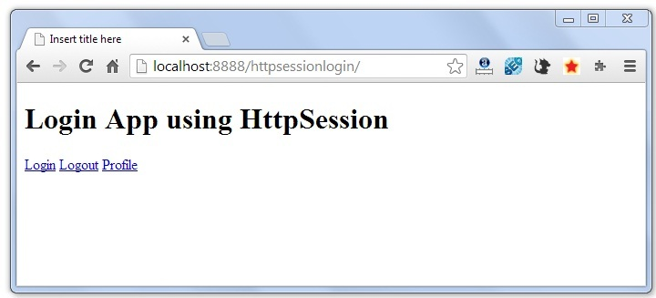 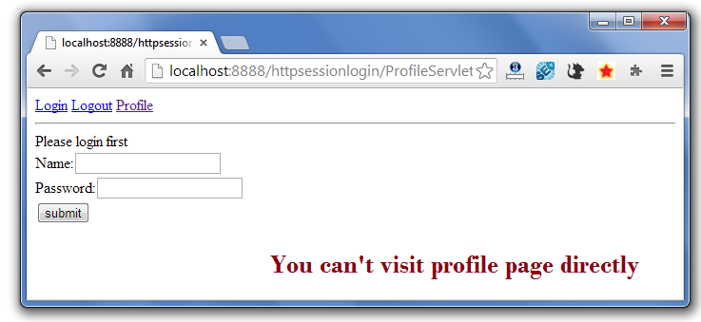 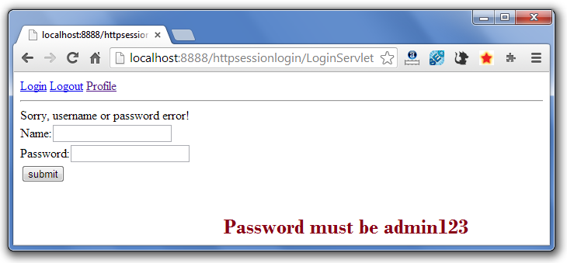 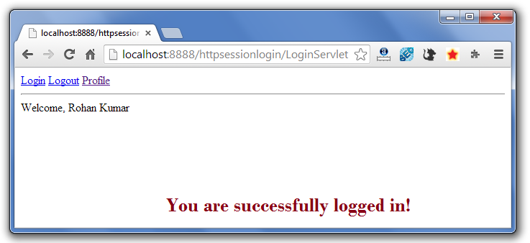 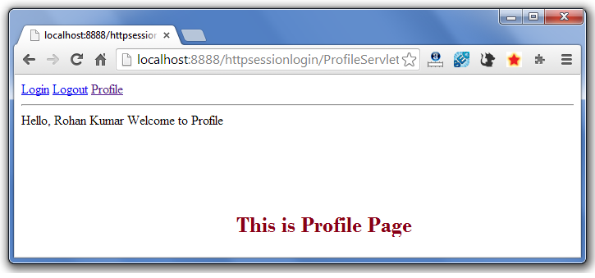 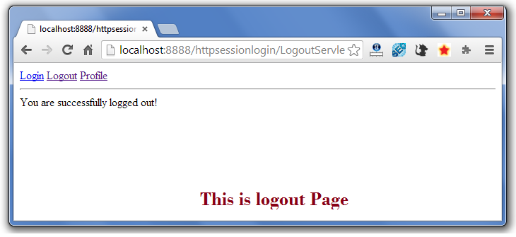**

**If again you click on the profile link, you need to login first.**

# Event and Listener in Servlet

Events are basically occurrence of something. Changing the state of an object is known as an event.

We can perform some important tasks at the occurrence of these exceptions, such as counting total and current logged-in users, creating tables of the database at time of deploying the project, creating database connection object etc.

There are many Event classes and Listener interfaces in the javax.servlet and javax.servlet.http packages.

## Event classes

The event classes are as follows:

1. ServletRequestEvent
2. ServletContextEvent
3. ServletRequestAttributeEvent
4. ServletContextAttributeEvent
5. HttpSessionEvent
6. HttpSessionBindingEvent

## Event interfaces

The event interfaces are as follows:

1. ServletRequestListener
2. ServletRequestAttributeListener
3. ServletContextListener
4. ServletContextAttributeListener
5. HttpSessionListener
6. HttpSessionAttributeListener
7. HttpSessionBindingListener
8. HttpSessionActivationListener

### Upcoming topics in Servlet Events and Listeners

[ServletContextEvent](http://www.javatpoint.com/ServletContextEvent)

Let's see the simple example of ServletContextEvent and ServletContextListener

[HttpSessionEvent](http://www.javatpoint.com/HttpSessionEvent)

Let's see the simple example of HttpSessionEvent and HttpSessionListener

[ServletRequestEvent](http://www.javatpoint.com/ServletRequestEvent)

Let's see the simple example of ServletRequestEvent and ServletRequestListener

[ServletContext AttributeEvent](http://www.javatpoint.com/ServletContextAttributeEvent)

Let's see the simple example of ServletContextAttributeEvent and ServletContextAttributeListener

[HttpSessionBindingEvent](http://www.javatpoint.com/HttpSessionBindingEvent)

Let's see the simple example of HttpSessionBindingEvent and HttpSessionAttributeListener

[ServletRequestAttributeEvent](http://www.javatpoint.com/ServletRequestAttributeEvent)

Let's see the simple example of ServletRequestAttributeEvent and ServletRequestAttributeEvent

# ServletContextEvent and ServletContextListener

1. [ServletContextEvent and ServletContextListener](http://www.javatpoint.com/ServletContextEvent)
2. [Constructor of ServletContextEvent class](http://www.javatpoint.com/ServletContextEvent#constructor)
3. [Method of ServletContextEvent class](http://www.javatpoint.com/ServletContextEvent#method)
4. [Methods of ServletContextListener interface](http://www.javatpoint.com/ServletContextEvent#methods)
5. [Example of ServletContextEvent and ServletContextListener](http://www.javatpoint.com/ServletContextEvent#ex1)
6. [Example of ServletContextListener to create table of a project](http://www.javatpoint.com/ServletContextEvent#ex2)

The ServletContextEvent is notified when web application is deployed on the server.

If you want to perform some action at the time of deploying the web application such as creating database connection, creating all the tables of the project etc, you need to implement ServletContextListener interface and provide the implementation of its methods.

### Constructor of ServletContextEvent class

There is only one constructor defined in the ServletContextEvent class. The web container creates the instance of ServletContextEvent after the ServletContext instance.

1. ServletContextEvent(ServletContext e)

### Method of ServletContextEvent class

There is only one method defined in the ServletContextEvent class:

1. **public ServletContext getServletContext()**: returns the instance of ServletContext.

### Methods of ServletContextListener interface

There are two methods declared in the ServletContextListener interface which must be implemented by the servlet programmer to perform some action such as creating database connection etc.

1. **public void contextInitialized(ServletContextEvent e)**: is invoked when application is deployed on the server.
2. **public void contextDestroyed(ServletContextEvent e)**: is invoked when application is undeployed from the server.

### Example of ServletContextEvent and ServletContextListener

In this example, we are retrieving the data from the emp32 table. To serve this, we have created the connection object in the listener class and used the connection object in the servlet.

**index.html**

1. <a href="servlet1">fetch records</a>

**MyListener.java**

1. **import** javax.servlet.*;
2. **import** java.sql.*;
4. **public** **class** MyListener **implements** ServletContextListener{
5. **public** **void** contextInitialized(ServletContextEvent event) {
6. **try**{
7. Class.forName("oracle.jdbc.driver.OracleDriver");
8. Connection con=DriverManager.getConnection(
9. "jdbc:oracle:thin:@localhost:1521:xe","system","oracle");
11. //storing connection object as an attribute in ServletContext
12. ServletContext ctx=event.getServletContext();
13. ctx.setAttribute("mycon", con);
15. }**catch**(Exception e){e.printStackTrace();}
16. }
18. **public** **void** contextDestroyed(ServletContextEvent arg0) {}
19. }

**MyListener.java**

1. **import** java.io.*;
2. **import** javax.servlet.*;
3. **import** javax.servlet.http.*;
4. **import** java.sql.*;
6. **public** **class** FetchData **extends** HttpServlet {
8. **public** **void** doGet(HttpServletRequest request, HttpServletResponse response)
9. **throws** ServletException, IOException {
11. response.setContentType("text/html");
12. PrintWriter out = response.getWriter();
14. **try**{
15. //Retrieving connection object from ServletContext object
16. ServletContext ctx=getServletContext();
17. Connection con=(Connection)ctx.getAttribute("mycon");
19. //retieving data  from emp32 table
20. PreparedStatement ps=con.prepareStatement("select * from emp32",
21. ResultSet.TYPE_SCROLL_SENSITIVE,ResultSet.CONCUR_UPDATABLE);
23. ResultSet rs=ps.executeQuery();
24. **while**(rs.next()){
25. out.print("<br>"+rs.getString(1)+" "+rs.getString(2));
26. }
28. con.close();
29. }**catch**(Exception e){e.printStackTrace();}
31. out.close();
32. }
33. }

[download this example (developed using Myeclipse IDE)](http://www.javatpoint.com/src/servlet/fetchservletcontextevent.zip)

### Example of ServletContextListener to create table of a project

In this example, we are creating table of the project. So we don't need to create all the tables manually in the database.

**MyListener.java**

1. **import** javax.servlet.*;
2. **import** java.sql.*;
4. **public** **class** MyListener **implements** ServletContextListener{
6. **public** **void** contextInitialized(ServletContextEvent arg0) {
7. **try**{
8. Class.forName("oracle.jdbc.driver.OracleDriver");
9. Connection con=DriverManager.getConnection("
10. jdbc:oracle:thin:@localhost:1521:xe","system","oracle");
12. String query="create table emp32(id number(10),name varchar2(40))";
13. PreparedStatement ps=con.prepareStatement(query);
14. ps.executeUpdate();
16. System.out.println(query);
18. }**catch**(Exception e){e.printStackTrace();}
19. }
21. **public** **void** contextDestroyed(ServletContextEvent arg0) {
22. System.out.println("project undeployed");
24. }
25. }

[download this example](http://www.javatpoint.com/src/servlet/contexteventcreatetables.zip)

### Other Examples of ServletContextListener

[**Example of ServletContextListener to improve performance**](http://www.javatpoint.com/improving-servlet-performance-to-fetch-records)

# HttpSessionEvent and HttpSessionListener

1. [HttpSessionEvent and HttpSessionListener](http://www.javatpoint.com/HttpSessionEvent)
2. [Methods of HttpSessionListener interface](http://www.javatpoint.com/HttpSessionEvent#methods)
3. [Example of HttpSessionEvent and HttpSessionListener to count total and current logged-in users](http://www.javatpoint.com/HttpSessionEvent#ex)

|  |
| --- |
| The HttpSessionEvent is notified when session object is changed. The corresponding Listener interface for this event is HttpSessionListener. |

|  |
| --- |
| We can perform some operations at this event such as counting total and current logged-in users, maintaing a log of user details such as login time, logout time etc. |

### Methods of HttpSessionListener interface

|  |
| --- |
| There are two methods declared in the HttpSessionListener interface which must be implemented by the servlet programmer to perform some action.   1. **public void sessionCreated(HttpSessionEvent e)**: is invoked when session object is created. 2. **public void sessionDestroyed(ServletContextEvent e)**: is invoked when session is invalidated. |

### Example of HttpSessionEvent and HttpSessionListener to count total and current logged-in users

|  |
| --- |
| In this example, are counting the total and current logged-in users. For this purpose, we have created three files:   1. **index.html**: to get input from the user. 2. **MyListener.java**: A listener class that counts total and current logged-in users and stores this information in ServletContext object as an attribute. 3. **First.java**: A Servlet class that creates session and prints the total and current logged-in users. 4. **Logout.java**: A Servlet class that invalidates session. |

#### index.html

1. <form action="servlet1">
2. Name:<input type="text" name="username"><br>
3. Password:<input type="password" name="userpass"><br>
5. <input type="submit" value="login"/>
6. </form>

#### MyListener.java

1. **import** javax.servlet.ServletContext;
2. **import** javax.servlet.http.HttpSessionEvent;
3. **import** javax.servlet.http.HttpSessionListener;
5. **public** **class** CountUserListener **implements** HttpSessionListener{
6. ServletContext ctx=**null**;
7. **static** **int** total=0,current=0;
9. **public** **void** sessionCreated(HttpSessionEvent e) {
10. total++;
11. current++;
13. ctx=e.getSession().getServletContext();
14. ctx.setAttribute("totalusers", total);
15. ctx.setAttribute("currentusers", current);
17. }
19. **public** **void** sessionDestroyed(HttpSessionEvent e) {
20. current--;
21. ctx.setAttribute("currentusers",current);
22. }
24. }

#### First.java

1. **import** java.io.IOException;
2. **import** java.io.PrintWriter;
4. **import** javax.servlet.ServletContext;
5. **import** javax.servlet.ServletException;
6. **import** javax.servlet.http.HttpServlet;
7. **import** javax.servlet.http.HttpServletRequest;
8. **import** javax.servlet.http.HttpServletResponse;
9. **import** javax.servlet.http.HttpSession;
11. **public** **class** First **extends** HttpServlet {
12. **public** **void** doGet(HttpServletRequest request,
13. HttpServletResponse response)
14. **throws** ServletException, IOException {
16. response.setContentType("text/html");
17. PrintWriter out = response.getWriter();
19. String n=request.getParameter("username");
20. out.print("Welcome "+n);
22. HttpSession session=request.getSession();
23. session.setAttribute("uname",n);
25. //retrieving data from ServletContext object
26. ServletContext ctx=getServletContext();
27. **int** t=(Integer)ctx.getAttribute("totalusers");
28. **int** c=(Integer)ctx.getAttribute("currentusers");
29. out.print("<br>total users= "+t);
30. out.print("<br>current users= "+c);
32. out.print("<br><a href='logout'>logout</a>");
34. out.close();
35. }
37. }

#### Logout.java

1. **import** java.io.IOException;
2. **import** java.io.PrintWriter;
4. **import** javax.servlet.ServletException;
5. **import** javax.servlet.http.HttpServlet;
6. **import** javax.servlet.http.HttpServletRequest;
7. **import** javax.servlet.http.HttpServletResponse;
8. **import** javax.servlet.http.HttpSession;

11. **public** **class** LogoutServlet **extends** HttpServlet {
12. **public** **void** doGet(HttpServletRequest request,
13. HttpServletResponse response)
14. **throws** ServletException, IOException {
16. response.setContentType("text/html");
17. PrintWriter out = response.getWriter();
19. HttpSession session=request.getSession(**false**);
20. session.invalidate();//invalidating session
22. out.print("You are successfully logged out");

25. out.close();
26. }
28. }

# Servlet Filter

1. [Filter](http://www.javatpoint.com/servlet-filter)
2. [Usage of Filter](http://www.javatpoint.com/servlet-filter#filterusage)
3. [Advantage of Filter](http://www.javatpoint.com/servlet-filter#filteradvantage)
4. [Filter API](http://www.javatpoint.com/servlet-filter#filterapi)
   1. [Filter interface](http://www.javatpoint.com/servlet-filter#filterinterface)
   2. [FilterChain interface](http://www.javatpoint.com/servlet-filter#filterchain)
   3. [FilterConfig interface](http://www.javatpoint.com/servlet-filter#filterconfig)
5. [Simple Example of Filter](http://www.javatpoint.com/servlet-filter#filterex)

A **filter** is an object that is invoked at the preprocessing and postprocessing of a request.

It is mainly used to perform filtering tasks such as conversion, logging, compression, encryption and decryption, input validation etc.

The **servlet filter is pluggable**, i.e. its entry is defined in the web.xml file, if we remove the entry of filter from the web.xml file, filter will be removed automatically and we don't need to change the servlet.

So maintenance cost will be less.

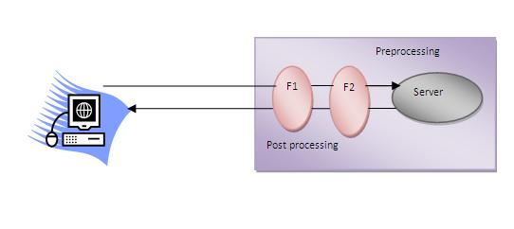

#### Note: Unlike Servlet, One filter doesn't have dependency on another filter.

### Usage of Filter

* recording all incoming requests
* logs the IP addresses of the computers from which the requests originate
* conversion
* data compression
* encryption and decryption
* input validation etc.

### Advantage of Filter

1. Filter is pluggable.
2. One filter don't have dependency onto another resource.
3. Less Maintenance

### Filter API

Like servlet filter have its own API. The javax.servlet package contains the three interfaces of Filter API.

1. Filter
2. FilterChain
3. FilterConfig

### 1) Filter interface

For creating any filter, you must implement the Filter interface. Filter interface provides the life cycle methods for a filter.

|  |  |
| --- | --- |
| **Method** | **Description** |
| public void init(FilterConfig config) | init() method is invoked only once. It is used to initialize the filter. |
| public void doFilter(HttpServletRequest request,HttpServletResponse response, FilterChain chain) | doFilter() method is invoked every time when user request to any resource, to which the filter is mapped.It is used to perform filtering tasks. |
| public void destroy() | This is invoked only once when filter is taken out of the service. |

### 2) FilterChain interface

The object of FilterChain is responsible to invoke the next filter or resource in the chain.This object is passed in the doFilter method of Filter interface.The FilterChain interface contains only one method:

1. **public void doFilter(HttpServletRequest request, HttpServletResponse response):** it passes the control to the next filter or resource.

### How to define Filter

We can define filter same as servlet. Let's see the elements of filter and filter-mapping.

1. <web-app>
3. <filter>
4. <filter-name>...</filter-name>
5. <filter-**class**>...</filter-**class**>
6. </filter>
8. <filter-mapping>
9. <filter-name>...</filter-name>
10. <url-pattern>...</url-pattern>
11. </filter-mapping>
13. </web-app>

For mapping filter we can use, either url-pattern or servlet-name. The url-pattern elements has an advantage over servlet-name element i.e. it can be applied on servlet, JSP or HTML.

### Simple Example of Filter

In this example, we are simply displaying information that filter is invoked automatically after the post processing of the request.

### index.html

1. <a href="servlet1">click here</a>

### MyFilter.java

1. **import** java.io.IOException;
2. **import** java.io.PrintWriter;
4. **import** javax.servlet.*;
6. **public** **class** MyFilter **implements** Filter{
8. **public** **void** init(FilterConfig arg0) **throws** ServletException {}
10. **public** **void** doFilter(ServletRequest req, ServletResponse resp,
11. FilterChain chain) **throws** IOException, ServletException {
13. PrintWriter out=resp.getWriter();
14. out.print("filter is invoked before");
16. chain.doFilter(req, resp);//sends request to next resource
18. out.print("filter is invoked after");
19. }
20. **public** **void** destroy() {}
21. }

### HelloServlet.java

1. **import** java.io.IOException;
2. **import** java.io.PrintWriter;
4. **import** javax.servlet.ServletException;
5. **import** javax.servlet.http.*;
7. **public** **class** HelloServlet **extends** HttpServlet {
8. **public** **void** doGet(HttpServletRequest request, HttpServletResponse response)
9. **throws** ServletException, IOException {
11. response.setContentType("text/html");
12. PrintWriter out = response.getWriter();
14. out.print("<br>welcome to servlet<br>");
16. }
18. }

**web.xml**

|  |
| --- |
| For defining the filter, filter element of web-app must be defined just like servlet. |

1. <web-app>
3. <servlet>
4. <servlet-name>s1</servlet-name>
5. <servlet-**class**>HelloServlet</servlet-**class**>
6. </servlet>
8. <servlet-mapping>
9. <servlet-name>s1</servlet-name>
10. <url-pattern>/servlet1</url-pattern>
11. </servlet-mapping>
13. <filter>
14. <filter-name>f1</filter-name>
15. <filter-**class**>MyFilter</filter-**class**>
16. </filter>
18. <filter-mapping>
19. <filter-name>f1</filter-name>
20. <url-pattern>/servlet1</url-pattern>
21. </filter-mapping>

24. </web-app>

# Authentication Filter

We can perform authentication in filter. Here, we are going to check to password given by the user in filter class, if given password is admin, it will forward the request to the WelcomeAdmin servlet otherwise it will display error message.

### Example of authenticating user using filter

Let's see the simple example of authenticating user using filter.

Here, we have created 4 files:

* index.html
* MyFilter.java
* AdminServlet.java
* web.xml

**index.html**

1. <form action="servlet1">
2. Name:<input type="text" name="name"/><br/>
3. Password:<input type="password" name="password"/><br/>
5. <input type="submit" value="login">
7. </form>

**MyFilter.java**

1. **import** java.io.IOException;
2. **import** java.io.PrintWriter;
3. **import** javax.servlet.*;
5. **public** **class** MyFilter **implements** Filter{
7. **public** **void** init(FilterConfig arg0) **throws** ServletException {}
9. **public** **void** doFilter(ServletRequest req, ServletResponse resp,
10. FilterChain chain) **throws** IOException, ServletException {
12. PrintWriter out=resp.getWriter();
14. String password=req.getParameter("password");
15. **if**(password.equals("admin")){
16. chain.doFilter(req, resp);//sends request to next resource
17. }
18. **else**{
19. out.print("username or password error!");
20. RequestDispatcher rd=req.getRequestDispatcher("index.html");
21. rd.include(req, resp);
22. }
24. }
25. **public** **void** destroy() {}
27. }

**AdminServlet.java**

1. **import** java.io.IOException;
2. **import** java.io.PrintWriter;
4. **import** javax.servlet.ServletException;
5. **import** javax.servlet.http.*;
7. **public** **class** AdminServlet **extends** HttpServlet {
8. **public** **void** doGet(HttpServletRequest request, HttpServletResponse response)
9. **throws** ServletException, IOException {
11. response.setContentType("text/html");
12. PrintWriter out = response.getWriter();
14. out.print("welcome ADMIN");
15. out.close();
16. }
17. }

**web.xml**

1. <web-app>
2. <servlet>
3. <servlet-name>AdminServlet</servlet-name>
4. <servlet-**class**>AdminServlet</servlet-**class**>
5. </servlet>
7. <servlet-mapping>
8. <servlet-name>AdminServlet</servlet-name>
9. <url-pattern>/servlet1</url-pattern>
10. </servlet-mapping>
12. <filter>
13. <filter-name>f1</filter-name>
14. <filter-**class**>MyFilter</filter-**class**>
15. </filter>
16. <filter-mapping>
17. <filter-name>f1</filter-name>
18. <url-pattern>/servlet1</url-pattern>
19. </filter-mapping>
21. </web-app>

# FilterConfig

An object of FilterConfig is created by the web container. This object can be used to get the configuration information from the web.xml file.

## Methods of FilterConfig interface

There are following 4 methods in the FilterConfig interface.

1. **public void init(FilterConfig config):** init() method is invoked only once it is used to initialize the filter.
2. **public String getInitParameter(String parameterName):** Returns the parameter value for the specified parameter name.
3. **public java.util.Enumeration getInitParameterNames():** Returns an enumeration containing all the parameter names.
4. **public ServletContext getServletContext():** Returns the ServletContext object.

### Example of FilterConfig

In this example, if you change the param-value to no, request will be forwarded to the servlet otherwise filter will create the response with the message: this page is underprocessing. Let's see the simple example of FilterConfig. Here, we have created 4 files:

* index.html
* MyFilter.java
* HelloServlet.java
* web.xml

1. <a href="servlet1">click here</a>

**MyFilter.java**

1. **import** java.io.IOException;
2. **import** java.io.PrintWriter;
4. **import** javax.servlet.*;
6. **public** **class** MyFilter **implements** Filter{
7. FilterConfig config;
9. **public** **void** init(FilterConfig config) **throws** ServletException {
10. **this**.config=config;
11. }
13. **public** **void** doFilter(ServletRequest req, ServletResponse resp,
14. FilterChain chain) **throws** IOException, ServletException {
16. PrintWriter out=resp.getWriter();
18. String s=config.getInitParameter("construction");
20. **if**(s.equals("yes")){
21. out.print("This page is under construction");
22. }
23. **else**{
24. chain.doFilter(req, resp);//sends request to next resource
25. }
27. }
28. **public** **void** destroy() {}
29. }

**HelloServlet.java**

1. **import** java.io.IOException;
2. **import** java.io.PrintWriter;
4. **import** javax.servlet.ServletException;
5. **import** javax.servlet.http.*;
7. **public** **class** HelloServlet **extends** HttpServlet {
8. **public** **void** doGet(HttpServletRequest request, HttpServletResponse response)
9. **throws** ServletException, IOException {
11. response.setContentType("text/html");
12. PrintWriter out = response.getWriter();
14. out.print("<br>welcome to servlet<br>");
16. }
18. }

**web.xml**

1. <web-app>
3. <servlet>
4. <servlet-name>HelloServlet</servlet-name>
5. <servlet-**class**>HelloServlet</servlet-**class**>
6. </servlet>
8. <servlet-mapping>
9. <servlet-name>HelloServlet</servlet-name>
10. <url-pattern>/servlet1</url-pattern>
11. </servlet-mapping>
13. <filter>
14. <filter-name>f1</filter-name>
15. <filter-**class**>MyFilter</filter-**class**>
16. <init-param>
17. <param-name>construction</param-name>
18. <param-value>no</param-value>
19. </init-param>
20. </filter>
21. <filter-mapping>
22. <filter-name>f1</filter-name>
23. <url-pattern>/servlet1</url-pattern>
24. </filter-mapping>

27. </web-app>

# Useful Filter Examples

There is given some useful examples of filter.

### Example of sending response by filter only

**MyFilter.java**

1. **import** java.io.*;
2. **import** javax.servlet.*;
4. **public** **class** MyFilter **implements** Filter{
5. **public** **void** init(FilterConfig arg0) **throws** ServletException {}
7. **public** **void** doFilter(ServletRequest req, ServletResponse res,
8. FilterChain chain) **throws** IOException, ServletException {
10. PrintWriter out=res.getWriter();
12. out.print("<br/>this site is underconstruction..");
13. out.close();
15. }
16. **public** **void** destroy() {}
17. }

### Example of counting number of visitors for a single page

**MyFilter.java**

1. **import** java.io.*;
2. **import** javax.servlet.*;
4. **public** **class** MyFilter **implements** Filter{
5. **static** **int** count=0;
6. **public** **void** init(FilterConfig arg0) **throws** ServletException {}
8. **public** **void** doFilter(ServletRequest req, ServletResponse res,
9. FilterChain chain) **throws** IOException, ServletException {
11. PrintWriter out=res.getWriter();
12. chain.doFilter(request,response);
14. out.print("<br/>Total visitors "+(++count));
15. out.close();
17. }
18. **public** **void** destroy() {}
19. }

### Example of checking total response time in filter

**MyFilter.java**

1. **import** java.io.*;
2. **import** javax.servlet.*;
4. **public** **class** MyFilter **implements** Filter{
5. **static** **int** count=0;
6. **public** **void** init(FilterConfig arg0) **throws** ServletException {}
8. **public** **void** doFilter(ServletRequest req, ServletResponse res,
9. FilterChain chain) **throws** IOException, ServletException {
11. PrintWriter out=res.getWriter();
12. **long** before=System.currentTimeMillis();
14. chain.doFilter(request,response);
16. **long** after=System.currentTimeMillis();
17. out.print("<br/>Total response time "+(after-before)+" miliseconds");
18. out.close();
20. }
21. **public** **void** destroy() {}
22. }

# ServletInputStream class

1. [ServletInputStream class](http://www.javatpoint.com/ServletInputStream-class)
2. [Method of ServletInputStream class](http://www.javatpoint.com/ServletInputStream-class)

**ServletInputStream** class provides stream to read binary data such as image etc. from the request object. It is an abstract class.

The **getInputStream()** method of **ServletRequest** interface returns the instance of ServletInputStream class. So can be get as:

1. ServletInputStream sin=request.getInputStream();

### Method of ServletInputStream class

There are only one method defined in the ServletInputStream class.

1. **int readLine(byte[] b, int off, int len)**it reads the input stream.

# ServletOutputStream class

1. [ServletOutputStream class](http://www.javatpoint.com/ServletOutputStream-class)
2. [Methods of ServletOutputStream class](http://www.javatpoint.com/ServletOutputStream-class#method)
3. [Example of ServletOutputStream class](http://www.javatpoint.com/ServletOutputStream-class)

**ServletOutputStream** class provides a stream to write binary data into the response. It is an abstract class.

The **getOutputStream()** method of **ServletResponse** interface returns the instance of ServletOutputStream class. It may be get as:

1. ServletOutputStream out=response.getOutputStream();

### Methods of ServletOutputStream class

The ServletOutputStream class provides print() and println() methods that are overloaded.

1. void print(boolean b){}
2. void print(char c){}
3. void print(int i){}
4. void print(long l){}
5. void print(float f){}
6. void print(double d){}
7. void print(String s){}
8. void println{}
9. void println(boolean b){}
10. void println(char c){}
11. void println(int i){}
12. void println(long l){}
13. void println(float f){}
14. void println(double d){}
15. void println(String s){}

### Example of ServletOutputStream class

[**Example of ServletOutputStream class to write image**](http://www.javatpoint.com/example-to-display-image-using-servlet)

# Servlet with Annotation (feature of servlet3):

1. [Servlet with Annotation](http://www.javatpoint.com/servlet-with-annotation)
2. [Example of simple servlet by annotation](http://www.javatpoint.com/servlet-with-annotation#ex)

Annotation represents the metadata. If you use annotation, deployment descriptor (web.xml file) is not required. But you should have tomcat7 as it will not run in the previous versions of tomcat. @WebServlet annotation is used to map the servlet with the specified name.

### Example of simple servlet by annotation

There is given the simple example of servlet with annotation.

### Simple.java

1. **import** java.io.IOException;
2. **import** java.io.PrintWriter;
4. **import** javax.servlet.ServletException;
5. **import** javax.servlet.annotation.WebServlet;
6. **import** javax.servlet.http.HttpServlet;
7. **import** javax.servlet.http.HttpServletRequest;
8. **import** javax.servlet.http.HttpServletResponse;
10. @WebServlet("/Simple")
11. **public** **class** Simple **extends** HttpServlet {
12. **private** **static** **final** **long** serialVersionUID = 1L;
14. **protected** **void** doGet(HttpServletRequest request, HttpServletResponse response)
15. **throws** ServletException, IOException {

18. response.setContentType("text/html");
19. PrintWriter out=response.getWriter();
21. out.print("<html><body>");
22. out.print("<h3>Hello Servlet</h3>");
23. out.print("</body></html>");
24. }
25. }

Pagination in Servlet

To divide large number of records into multiple parts, we use pagination. It allows user to display a part of records only. Loading all records in a single page may take time, so it is always recommended to created pagination. In servlet, we can develop pagination example easily.

In this servlet pagination example, we are using MySQL database to fetch records.

Here, we have created "emp" table in "test" database. The emp table has three fields: id, name and salary. Either create table and insert records manually or import our sql file.

index.html

1. **<a** href="ViewServlet?page=1"**>**View Employees**</a>**

ViewServlet.java

1. package com.javatpoint.servlets;
3. import java.io.IOException;
4. import java.io.PrintWriter;
5. import java.util.List;
6. import javax.servlet.ServletException;
7. import javax.servlet.annotation.WebServlet;
8. import javax.servlet.http.HttpServlet;
9. import javax.servlet.http.HttpServletRequest;
10. import javax.servlet.http.HttpServletResponse;
11. import com.javatpoint.beans.Emp;
12. import com.javatpoint.dao.EmpDao;
14. @WebServlet("/ViewServlet")
15. public class ViewServlet extends HttpServlet {
16. private static final long serialVersionUID = 1L;
17. protected void doGet(HttpServletRequest request, HttpServletResponse response)
18. throws ServletException, IOException {
19. response.setContentType("text/html");
20. PrintWriter out=response.getWriter();
22. String spageid=request.getParameter("page");
23. int pageid=Integer.parseInt(spageid);
24. int total=5;
25. if(pageid==1){}
26. else{
27. pageidpageid=pageid-1;
28. pageidpageid=pageid*total+1;
29. }
30. List**<Emp>** list=EmpDao.getRecords(pageid,total);
32. out.print("**<h1>**Page No: "+spageid+"**</h1>**");
33. out.print("**<table** border='1' cellpadding='4' width='60%'**>**");
34. out.print("**<tr><th>**Id**</th><th>**Name**</th><th>**Salary**</th>**");
35. for(Emp e:list){
36. out.print("**<tr><td>**"+e.getId()+"**</td><td>**"+e.getName()+"**</td><td>**"+e.getSalary()+"**</td></tr>**");
37. }
38. out.print("**</table>**");
40. out.print("**<a** href='ViewServlet?page=1'**>**1**</a>** ");
41. out.print("**<a** href='ViewServlet?page=2'**>**2**</a>** ");
42. out.print("**<a** href='ViewServlet?page=3'**>**3**</a>** ");
44. out.close();
45. }
46. }

Emp.java

1. **package** com.javatpoint.beans;
3. **public** **class** Emp {
4. **private** **int** id;
5. **private** String name;
6. **private** **float** salary;
7. //getters and setters
8. }

EmpDao.java

1. **package** com.javatpoint.dao;
2. **import** com.javatpoint.beans.*;
3. **import** java.sql.*;
4. **import** java.util.ArrayList;
5. **import** java.util.List;
6. **public** **class** EmpDao {
8. **public** **static** Connection getConnection(){
9. Connection con=**null**;
10. **try**{
11. Class.forName("com.mysql.jdbc.Driver");
12. con=DriverManager.getConnection("jdbc:mysql://localhost:3306/test","","");
13. }**catch**(Exception e){System.out.println(e);}
14. **return** con;
15. }
17. **public** **static** List<Emp> getRecords(**int** start,**int** total){
18. List<Emp> list=**new** ArrayList<Emp>();
19. **try**{
20. Connection con=getConnection();
21. PreparedStatement ps=con.prepareStatement("select * from emp limit "+(start-1)+","+total);
22. ResultSet rs=ps.executeQuery();
23. **while**(rs.next()){
24. Emp e=**new** Emp();
25. e.setId(rs.getInt(1));
26. e.setName(rs.getString(2));
27. e.setSalary(rs.getFloat(3));
28. list.add(e);
29. }
30. con.close();
31. }**catch**(Exception e){System.out.println(e);}
32. **return** list;
33. }
34. }

Download SQL File

[Download SQL File](https://www.javatpoint.com/jsppages/src/emp.sql)

Download mysql-connector.jar file

[Download mysql-connector.jar](http://www.javatpoint.com/src/jdbc/mysql-connector.jar)

Download Project

[Download this example (Developed in Eclipse)](https://www.javatpoint.com/servletpages/src/servletpagination.zip)

Output

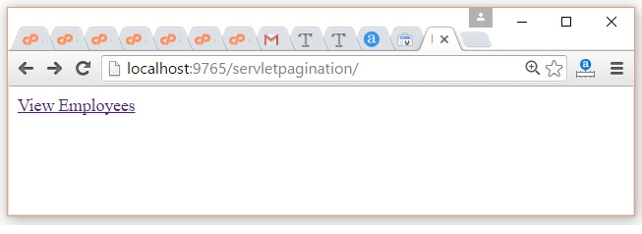 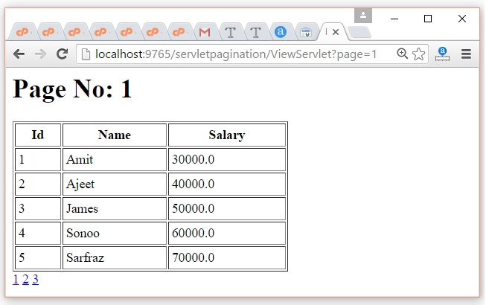 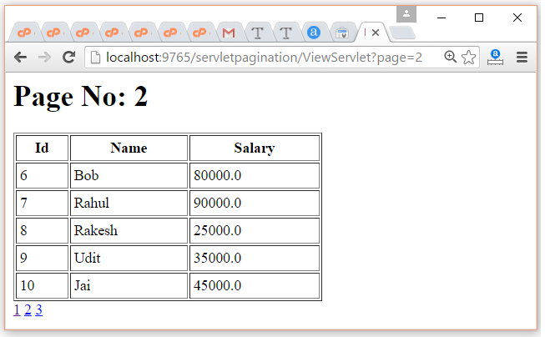 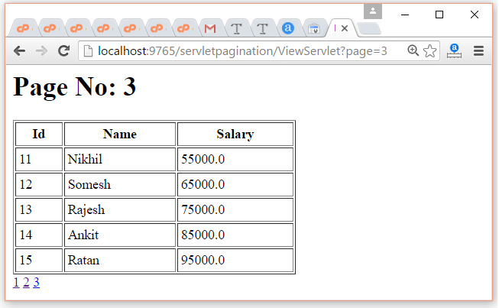

# Next

# SingleThreadModel interface

1. [SingleThreadModel interface](http://www.javatpoint.com/SingleThreadModel-interface)
2. [Example of SingleThreadModel interface](http://www.javatpoint.com/SingleThreadModel-interface#ex)

The servlet programmer should implement SingleThreadModel interface to ensure that servlet can handle only one request at a time. It is a marker interface, means have no methods.

This interface is currently deprecated since Servlet API 2.4 because it doesn't solves all the thread-safety issues such as static variable and session attributes can be accessed by multiple threads at the same time even if we have implemented the SingleThreadModel interface. So it is recommended to use other means to resolve these thread safety issues such as synchronized block etc.

### Example of SingleThreadModel interface

Let's see the simple example of implementing the SingleThreadModel interface.

1. **import** java.io.IOException;
2. **import** java.io.PrintWriter;
3. **import** javax.servlet.ServletException;
4. **import** javax.servlet.SingleThreadModel;
5. **import** javax.servlet.http.HttpServlet;
6. **import** javax.servlet.http.HttpServletRequest;
7. **import** javax.servlet.http.HttpServletResponse;
9. **public** **class** MyServlet **extends** HttpServlet **implements** SingleThreadModel{
10. **public** **void** doGet(HttpServletRequest request, HttpServletResponse response)
11. **throws** ServletException, IOException {
12. response.setContentType("text/html");
13. PrintWriter out = response.getWriter();
15. out.print("welcome");
16. **try**{Thread.sleep(10000);}**catch**(Exception e){e.printStackTrace();}
17. out.print(" to servlet");
18. out.close();
19. }
20. }
21. Server Side Include (SSI)
22. Thanks for your visit. This page is currently under processing....

# Example of Registration form in servlet

Here, you will learn that how to create simple registration form in servlet. We are using oracle10g database. So you need to create a table first as given below:

1. CREATE TABLE  "REGISTERUSER"
2. (    "NAME" VARCHAR2(4000),
3. "PASS" VARCHAR2(4000),
4. "EMAIL" VARCHAR2(4000),
5. "COUNTRY" VARCHAR2(4000)
6. )
7. /

To create the registration page in servlet, we can separate the database logic from the servlet. But here, we are mixing the database logic in the servlet only for simplicity of the program. We will develop this page in JSP following DAO, DTO and Singleton design pattern later.

### Example of Registration form in servlet

In this example, we have created the three pages.

* register.html
* Register.java
* web.xml

**register.html**

In this page, we have getting input from the user using text fields and combobox. The information entered by the user is forwarded to Register servlet, which is responsible to store the data into the database.

1. <html>
2. <body>
3. <form action="servlet/Register" method="post">
5. Name:<input type="text" name="userName"/><br/><br/>
6. Password:<input type="password" name="userPass"/><br/><br/>
7. Email Id:<input type="text" name="userEmail"/><br/><br/>
8. Country:
9. <select name="userCountry">
10. <option>India</option>
11. <option>Pakistan</option>
12. <option>other</option>
13. </select>
15. <br/><br/>
16. <input type="submit" value="register"/>
18. </form>
19. </body>
20. </html>

**Register.java**

This servlet class receives all the data entered by user and stores it into the database. Here, we are performing the database logic. But you may separate it, which will be better for the web application.

1. **import** java.io.*;
2. **import** java.sql.*;
3. **import** javax.servlet.ServletException;
4. **import** javax.servlet.http.*;
6. **public** **class** Register **extends** HttpServlet {
7. **public** **void** doPost(HttpServletRequest request, HttpServletResponse response)
8. **throws** ServletException, IOException {
10. response.setContentType("text/html");
11. PrintWriter out = response.getWriter();
13. String n=request.getParameter("userName");
14. String p=request.getParameter("userPass");
15. String e=request.getParameter("userEmail");
16. String c=request.getParameter("userCountry");
18. **try**{
19. Class.forName("oracle.jdbc.driver.OracleDriver");
20. Connection con=DriverManager.getConnection(
21. "jdbc:oracle:thin:@localhost:1521:xe","system","oracle");
23. PreparedStatement ps=con.prepareStatement(
24. "insert into registeruser values(?,?,?,?)");
26. ps.setString(1,n);
27. ps.setString(2,p);
28. ps.setString(3,e);
29. ps.setString(4,c);
31. **int** i=ps.executeUpdate();
32. **if**(i>0)
33. out.print("You are successfully registered...");

36. }**catch** (Exception e2) {System.out.println(e2);}
38. out.close();
39. }
41. }

**web.xml file**

The is the configuration file, providing information about the servlet.

1. <web-app>
3. <servlet>
4. <servlet-name>Register</servlet-name>
5. <servlet-**class**>Register</servlet-**class**>
6. </servlet>
8. <servlet-mapping>
9. <servlet-name>Register</servlet-name>
10. <url-pattern>/servlet/Register</url-pattern>
11. </servlet-mapping>
13. <welcome-file-list>
14. <welcome-file>register.html</welcome-file>
15. </welcome-file-list>
17. </web-app>

# Example of Fetching Result for the given rollno

Here, you will learn that how to fetch result for the given rollno. I am assuming that there is a table as given below:

1. CREATE TABLE  "RESULT"
2. (    "ROLLNO" NUMBER,
3. "NAME" VARCHAR2(40),
4. "RESULT" VARCHAR2(40),
5. "GRADE" VARCHAR2(40),
6. CONSTRAINT "RESULT_PK" PRIMARY KEY ("ROLLNO") ENABLE
7. )
8. /

We are assuming there are many records in this table. In this example, we are getting the data from the database in servlet and printing it. We are doing all the database logic in servlet for simplicity of the program. But it will be better to separate it from the servlet file.

### Example of Fetching Result for the given rollno

In this example, we have create three files

* index.html
* Search.java
* web.xml

**index.html**

This page gets rollno from the user and forwards this data to servlet which is responsible to show the records based on the given rollno.

1. <html>
2. <body>
3. <form action="servlet/Search">
4. Enter your Rollno:<input type="text" name="roll"/><br/>
6. <input type="submit" value="search"/>
7. </form>
8. </body>
9. </html>

**Search.java**

This is the servlet file which gets the input from the user and maps this data with the database and prints the record for the matched data. In this page, we are displaying the column name of the database along with data, so we are using ResultSetMetaData interface.

1. **import** java.io.*;
2. **import** java.sql.*;
3. **import** javax.servlet.ServletException;
4. **import** javax.servlet.http.*;
6. **public** **class** Search **extends** HttpServlet {
8. **public** **void** doGet(HttpServletRequest request, HttpServletResponse response)
9. **throws** ServletException, IOException {
11. response.setContentType("text/html");
12. PrintWriter out = response.getWriter();
14. String rollno=request.getParameter("roll");
15. **int** roll=Integer.valueOf(rollno);
17. **try**{
18. Class.forName("oracle.jdbc.driver.OracleDriver");
19. Connection con=DriverManager.getConnection(
20. "jdbc:oracle:thin:@localhost:1521:xe","system","oracle");
22. PreparedStatement ps=con.prepareStatement("select * from result where rollno=?");
23. ps.setInt(1,roll);
25. out.print("<table width=50% border=1>");
26. out.print("<caption>Result:</caption>");
28. ResultSet rs=ps.executeQuery();
30. /* Printing column names */
31. ResultSetMetaData rsmd=rs.getMetaData();
32. **int** total=rsmd.getColumnCount();
33. out.print("<tr>");
34. **for**(**int** i=1;i<=total;i++)
35. {
36. out.print("<th>"+rsmd.getColumnName(i)+"</th>");
37. }
39. out.print("</tr>");
41. /* Printing result */
43. **while**(rs.next())
44. {
45. out.print("<tr><td>"+rs.getInt(1)+"</td><td>"+rs.getString(2)+"
46. </td><td>"+rs.getString(3)+"</td><td>"+rs.getString(4)+"</td></tr>");
48. }
50. out.print("</table>");
52. }**catch** (Exception e2) {e2.printStackTrace();}
54. **finally**{out.close();}
56. }
57. }

**web.xml file**

This is the configuration file which provides information of the servlet to the container.

1. <web-app>
3. <servlet>
4. <servlet-name>Search</servlet-name>
5. <servlet-**class**>Search</servlet-**class**>
6. </servlet>
8. <servlet-mapping>
9. <servlet-name>Search</servlet-name>
10. <url-pattern>/servlet/Search</url-pattern>
11. </servlet-mapping>
13. </web-app>

# Improving Servlet performance to fetch records from database

In this example, we are going to improve the performance of web application to fetch records from the database. To serve this, we are storing the data of the table in a collection, and reusing this collection in our servlet. So, we are not directly hitting the database again and again. By this, we are improving the performance.

To run this application, you need to create following table with some records.

1. CREATE TABLE  "CSUSER"
2. (    "USERID" NUMBER,
3. "USERNAME" VARCHAR2(4000),
4. "USERPASS" VARCHAR2(4000),
5. "USEREMAIL" VARCHAR2(4000),
6. "USERCOUNTRY" VARCHAR2(4000),
7. "CONTACT" NUMBER,
8. CONSTRAINT "CSUSER_PK" PRIMARY KEY ("USERID") ENABLE
9. )
10. /

### Example to Improve the performance of servlet to fetch records from database

In this example, we have created 6 pages.

1. **index.html**
2. **User.java**
3. **MyListener.java**
4. **MyServlet1.java**
5. **MyServlet2.java**
6. **web.xml**

**1) index.html**

This html file contains two links that sends request to the servlet.

1. <a href="servlet1">first servlet</a>|
2. <a href="servlet2">second servlet</a>

**2) User.java**

This is simple bean class containing 3 properties with its getters and setters. This class represents the table of the database.

1. **public** **class** User {
2. **private** **int** id;
3. **private** String name,password;
5. **public** **int** getId() {
6. **return** id;
7. }
8. **public** **void** setId(**int** id) {
9. **this**.id = id;
10. }
11. **public** String getName() {
12. **return** name;
13. }
14. **public** **void** setName(String name) {
15. **this**.name = name;
16. }
17. **public** String getPassword() {
18. **return** password;
19. }
20. **public** **void** setPassword(String password) {
21. **this**.password = password;
22. }

25. }

**3) MyListener.java**

It is the listener class. When the project will be deployed, contextInitialized method of ServletContextListener is invoked by default. Here, we are getting the records of the table and storing it in the User class object which is added in the ArrayList class object. At last, all the records of the table will be stored in the ArrayList class object (collection). Finally, we are storing the ArrayList object in the ServletConext object as an attribute so that we can get it in the servlet and use it.

1. **import** javax.servlet.ServletContext;
2. **import** javax.servlet.ServletContextEvent;
3. **import** javax.servlet.ServletContextListener;
4. **import** java.sql.*;
5. **import** java.util.ArrayList;
7. **public** **class** MyListener **implements** ServletContextListener{
9. **public** **void** contextInitialized(ServletContextEvent e) {
11. ArrayList list=**new** ArrayList();
12. **try**{
13. Class.forName("oracle.jdbc.driver.OracleDriver");
14. Connection con=DriverManager.getConnection(
15. "jdbc:oracle:thin:@localhost:1521:xe","system","oracle");
17. PreparedStatement ps=con.prepareStatement("select * from csuser");
18. ResultSet rs=ps.executeQuery();
19. **while**(rs.next()){
20. User u=**new** User();
21. u.setId(rs.getInt(1));
22. u.setName(rs.getString(2));
23. u.setPassword(rs.getString(3));
24. list.add(u);
25. }
26. con.close();
28. }**catch**(Exception ex){System.out.print(ex);}
30. //storing the ArrayList object in ServletContext
31. ServletContext context=e.getServletContext();
32. context.setAttribute("data",list);
34. }
35. **public** **void** contextDestroyed(ServletContextEvent arg0) {
36. System.out.println("project undeployed...");
37. }
39. }

**4) MyServlet1.java**

This servlet gets the information from the servlet context object and prints it.

1. **import** java.io.IOException;
2. **import** java.io.PrintWriter;
3. **import** java.sql.Connection;
4. **import** java.sql.DriverManager;
5. **import** java.sql.PreparedStatement;
6. **import** java.sql.ResultSet;
7. **import** java.util.Iterator;
8. **import** java.util.List;
10. **import** javax.servlet.ServletContext;
11. **import** javax.servlet.ServletException;
12. **import** javax.servlet.http.HttpServlet;
13. **import** javax.servlet.http.HttpServletRequest;
14. **import** javax.servlet.http.HttpServletResponse;

17. **public** **class** MyServlet1 **extends** HttpServlet {
18. **public** **void** doGet(HttpServletRequest request, HttpServletResponse
19. response)**throws** ServletException, IOException {
21. response.setContentType("text/html");
22. PrintWriter out = response.getWriter();
24. **long** before=System.currentTimeMillis();
26. ServletContext context=getServletContext();
27. List list=(List)context.getAttribute("data");
29. Iterator itr=list.iterator();
30. **while**(itr.hasNext()){
31. User u=(User)itr.next();
32. out.print("<br>"+u.getId()+" "+u.getName()+" "+u.getPassword());
33. }
35. **long** after=System.currentTimeMillis();
36. out.print("<br>total time :"+(after-before));
38. out.close();
39. }
41. }

**5) MyServlet2.java**

It is same as MyServlet1. This servlet gets the information from the servlet context object and prints it.

1. **import** java.io.IOException;
2. **import** java.io.PrintWriter;
3. **import** java.sql.Connection;
4. **import** java.sql.DriverManager;
5. **import** java.sql.PreparedStatement;
6. **import** java.sql.ResultSet;
7. **import** java.util.Iterator;
8. **import** java.util.List;
10. **import** javax.servlet.ServletContext;
11. **import** javax.servlet.ServletException;
12. **import** javax.servlet.http.HttpServlet;
13. **import** javax.servlet.http.HttpServletRequest;
14. **import** javax.servlet.http.HttpServletResponse;

17. **public** **class** MyServlet2 **extends** HttpServlet {
18. **public** **void** doGet(HttpServletRequest request, HttpServletResponse
19. response)**throws** ServletException, IOException {
21. response.setContentType("text/html");
22. PrintWriter out = response.getWriter();
24. **long** before=System.currentTimeMillis();
26. ServletContext context=getServletContext();
27. List list=(List)context.getAttribute("data");
29. Iterator itr=list.iterator();
30. **while**(itr.hasNext()){
31. User u=(User)itr.next();
32. out.print("<br>"+u.getId()+" "+u.getName()+" "+u.getPassword());
33. }
35. **long** after=System.currentTimeMillis();
36. out.print("<br>total time :"+(after-before));
38. out.close();
39. }
41. }

**6) web.xml**

Here we are containing the information about servlets and listener.

1. <?xml version="1.0" encoding="UTF-8"?>
2. <web-app version="2.5"
3. xmlns="http://java.sun.com/xml/ns/javaee"
4. xmlns:xsi="http://www.w3.org/2001/XMLSchema-instance"
5. xsi:schemaLocation="http://java.sun.com/xml/ns/javaee
6. http://java.sun.com/xml/ns/javaee/web-app_2_5.xsd">
8. <listener>
9. <listener-**class**>MyListener</listener-**class**>
10. </listener>
12. <servlet>
13. <servlet-name>MyServlet1</servlet-name>
14. <servlet-**class**>MyServlet1</servlet-**class**>
16. </servlet>
17. <servlet>
18. <servlet-name>MyServlet2</servlet-name>
19. <servlet-**class**>MyServlet2</servlet-**class**>
21. </servlet>
23. <servlet-mapping>
24. <servlet-name>MyServlet1</servlet-name>
25. <url-pattern>/servlet1</url-pattern>
26. </servlet-mapping>
27. <servlet-mapping>
28. <servlet-name>MyServlet2</servlet-name>
29. <url-pattern>/servlet2</url-pattern>
30. </servlet-mapping>
32. </web-app>

# Example of uploading file to the server in servlet

Here, we will learn how to upload file to the server. For uploading a file to the server, method must be post and enctype must be multipart/form-data in html file. For Example:

**index.html**

1. <html>
2. <body>
3. <form action="go" method="post" enctype="multipart/form-data">
4. Select File:<input type="file" name="fname"/><br/>
5. <input type="submit" value="upload"/>
6. </form>
7. </body>
8. </html>

### Example of uploading file to the server in servlet

Now, for uploading a file to the server, there can be various ways. But, I am going to use MultipartRequest class provided by oreilly. For using this class you must have cos.jar file. If you will download this example, we will the cos.jar file alongwith code.

**UploadServlet.java**

1. **import** java.io.*;
2. **import** javax.servlet.ServletException;
3. **import** javax.servlet.http.*;
4. **import** com.oreilly.servlet.MultipartRequest;
6. **public** **class** UploadServlet **extends** HttpServlet {
8. **public** **void** doPost(HttpServletRequest request, HttpServletResponse response)
9. **throws** ServletException, IOException {
11. response.setContentType("text/html");
12. PrintWriter out = response.getWriter();
14. MultipartRequest m=**new** MultipartRequest(request,"d:/new");
15. out.print("successfully uploaded");
16. }
17. }

There are two arguments passed in MultipartRequest class constructor, first one is HttpServletRequest object and second one is String object (for location). Here I am supposing that you have new folder in D driver.

**web.xml file**

This configuration file provides information about the servlet.

1. <web-app>
3. <servlet>
4. <servlet-name>UploadServlet</servlet-name>
5. <servlet-**class**>UploadServlet</servlet-**class**>
6. </servlet>
8. <servlet-mapping>
9. <servlet-name>UploadServlet</servlet-name>
10. <url-pattern>/go</url-pattern>
11. </servlet-mapping>
13. </web-app>

# Example of downloading file from the server in servlet

For downloading a file from the server, here is the simple example. I am supposing you have home.jsp file in E drive that you want to download. If there is any jar or zip file, you can direct provide a link to that file. So there is no need to write the program to download. But if there is any java file or jsp file etc, you need to create a program to download that file.

### Example of downloading file from the server in servlet

In this example, we are creating three files:

* index.html
* DownloadServlet.java
* web.xml

**index.html**

This file provides a link to download the file.

1. <a href="servlet/DownloadServlet">download the jsp file</a>

**DownloadServlet.java**

This is the servlet file that reads the content of the file and writes it into the stream to send as a response. For this purpose, we need to inform the server, so we are setting the content type as APPLICATION/OCTET-STREAM .

1. **import** java.io.*;
2. **import** javax.servlet.ServletException;
3. **import** javax.servlet.http.*;
5. **public** **class** DownloadServlet **extends** HttpServlet {
7. **public** **void** doGet(HttpServletRequest request, HttpServletResponse response)
8. **throws** ServletException, IOException {
10. response.setContentType("text/html");
11. PrintWriter out = response.getWriter();
12. String filename = "home.jsp";
13. String filepath = "e:\\";
14. response.setContentType("APPLICATION/OCTET-STREAM");
15. response.setHeader("Content-Disposition","attachment; filename=\"" + filename + "\"");
17. FileInputStream fileInputStream = **new** FileInputStream(filepath + filename);
19. **int** i;
20. **while** ((i=fileInputStream.read()) != -1) {
21. out.write(i);
22. }
23. fileInputStream.close();
24. out.close();
25. }
27. }

**web.xml file**

This configuration file provides informations to the server about the servlet.

1. <web-app>
3. <servlet>
4. <servlet-name>DownloadServlet</servlet-name>
5. <servlet-**class**>DownloadServlet</servlet-**class**>
6. </servlet>
8. <servlet-mapping>
9. <servlet-name>DownloadServlet</servlet-name>
10. <url-pattern>/servlet/DownloadServlet</url-pattern>
11. </servlet-mapping>
13. </web-app>

# Sending email through JavaMail API in Servlet

The JavaMail API provides many classes that can be used to send email from java. The javax.mail and javax.mail.internet packages contains all the classes required for sending and receiving emails.

For better understanding of this example click [steps for sending email from javamail api](http://www.javatpoint.com/example-of-sending-email-using-java-mail-api)

For sending the email using JavaMail API, you need to load the two jar files:

* **mail.jar**
* **activation.jar**

[download these jar files](http://www.javatpoint.com/src/mail/mailactivation.zip) or go to the Oracle site to download the latest version.

### Example of Sending email through JavaMail API in Servlet

Here is the simple example of sending email from servlet. For this example we are creating 3 files:

* index.html file for input
* SendMail.java , a servlet file for handling the request and providing the response to the user. It uses the send method of Mailer class to send the email.
* Mailer.java , a java class that contains send method to send the emails to the mentioned recipient.

**index.html**

1. <form action="servlet/SendMail">
2. To:<input type="text" name="to"/><br/>
3. Subject:<input type="text" name="subject"><br/>
4. Text:<textarea rows="10" cols="70" name="msg"></textarea><br/>
5. <input type="submit" value="send"/>
6. </form>

**SendMail.java**

1. **import** java.io.IOException;
2. **import** java.io.PrintWriter;
4. **import** javax.servlet.ServletException;
5. **import** javax.servlet.http.HttpServlet;
6. **import** javax.servlet.http.HttpServletRequest;
7. **import** javax.servlet.http.HttpServletResponse;

10. **public** **class** SendMail **extends** HttpServlet {
11. **public** **void** doGet(HttpServletRequest request,
12. HttpServletResponse response)
13. **throws** ServletException, IOException {
15. response.setContentType("text/html");
16. PrintWriter out = response.getWriter();
18. String to=request.getParameter("to");
19. String subject=request.getParameter("subject");
20. String msg=request.getParameter("msg");
22. Mailer.send(to, subject, msg);
23. out.print("message has been sent successfully");
24. out.close();
25. }
27. }

**Mailer.java**

1. **import** java.util.Properties;
3. **import** javax.mail.*;
4. **import** javax.mail.internet.InternetAddress;
5. **import** javax.mail.internet.MimeMessage;
7. **public** **class** Mailer {
8. **public** **static** **void** send(String to,String subject,String msg){
10. **final** String user="sonoojaiswal@javatpoint.com";//change accordingly
11. **final** String pass="xxxxx";
13. //1st step) Get the session object
14. Properties props = **new** Properties();
15. props.put("mail.smtp.host", "mail.javatpoint.com");//change accordingly
16. props.put("mail.smtp.auth", "true");
18. Session session = Session.getDefaultInstance(props,
19. **new** javax.mail.Authenticator() {
20. **protected** PasswordAuthentication getPasswordAuthentication() {
21. **return** **new** PasswordAuthentication(user,pass);
22. }
23. });
24. //2nd step)compose message
25. **try** {
26. MimeMessage message = **new** MimeMessage(session);
27. message.setFrom(**new** InternetAddress(user));
28. message.addRecipient(Message.RecipientType.TO,**new** InternetAddress(to));
29. message.setSubject(subject);
30. message.setText(msg);
32. //3rd step)send message
33. Transport.send(message);
35. System.out.println("Done");
37. } **catch** (MessagingException e) {
38. **throw** **new** RuntimeException(e);
39. }
41. }
42. }

Example of Login Form in Servlet Tutorial

Here, we are going to create the simple example to create the login form using servlet. We have used oracle10g as the database. There are 5 files required for this application.

* index.html
* FirstServlet.java
* LoginDao.java
* SecondServlet.java
* web.xml

You must need to create a table userreg with name and pass fields. Moreover, it must have contained some data. The table should be as:

1. create table userreg(name varchar2(40),pass varchar2(40));

**index.html**

1. <form action="servlet1" method="post">
2. Name:<input type="text" name="username"/><br/><br/>
3. Password:<input type="password" name="userpass"/><br/><br/>
4. <input type="submit" value="login"/>
5. </form>

**FirstServlet.java**

1. **import** java.io.IOException;
2. **import** java.io.PrintWriter;
4. **import** javax.servlet.RequestDispatcher;
5. **import** javax.servlet.ServletException;
6. **import** javax.servlet.http.HttpServlet;
7. **import** javax.servlet.http.HttpServletRequest;
8. **import** javax.servlet.http.HttpServletResponse;

11. **public** **class** FirstServlet **extends** HttpServlet {
12. **public** **void** doPost(HttpServletRequest request, HttpServletResponse response)
13. **throws** ServletException, IOException {
15. response.setContentType("text/html");
16. PrintWriter out = response.getWriter();
18. String n=request.getParameter("username");
19. String p=request.getParameter("userpass");
21. **if**(LoginDao.validate(n, p)){
22. RequestDispatcher rd=request.getRequestDispatcher("servlet2");
23. rd.forward(request,response);
24. }
25. **else**{
26. out.print("Sorry username or password error");
27. RequestDispatcher rd=request.getRequestDispatcher("index.html");
28. rd.include(request,response);
29. }
31. out.close();
32. }
33. }

**LoginDao.java**

1. **import** java.sql.*;
3. **public** **class** LoginDao {
4. **public** **static** **boolean** validate(String name,String pass){
5. **boolean** status=**false**;
6. **try**{
7. Class.forName("oracle.jdbc.driver.OracleDriver");
8. Connection con=DriverManager.getConnection(
9. "jdbc:oracle:thin:@localhost:1521:xe","system","oracle");
11. PreparedStatement ps=con.prepareStatement(
12. "select * from userreg where name=? and pass=?");
13. ps.setString(1,name);
14. ps.setString(2,pass);
16. ResultSet rs=ps.executeQuery();
17. status=rs.next();
19. }**catch**(Exception e){System.out.println(e);}
20. **return** status;
21. }
22. }

**WelcomeServlet.java**

1. **import** java.io.IOException;
2. **import** java.io.PrintWriter;
4. **import** javax.servlet.ServletException;
5. **import** javax.servlet.http.HttpServlet;
6. **import** javax.servlet.http.HttpServletRequest;
7. **import** javax.servlet.http.HttpServletResponse;
9. **public** **class** WelcomeServlet **extends** HttpServlet {
10. **public** **void** doPost(HttpServletRequest request, HttpServletResponse response)
11. **throws** ServletException, IOException {
13. response.setContentType("text/html");
14. PrintWriter out = response.getWriter();
16. String n=request.getParameter("username");
17. out.print("Welcome "+n);
19. out.close();
20. }
22. }

Example to display image using Servlet

In this example, we are using **FileInputStream** class to read image and **ServletOutputStream** class for writing this image content as a response. To make the performance faster, we have used BufferedInputStream and BufferedOutputStream class.

You need to use the content type **image/jpeg**.

In this example, we are assuming that you have java.jpg image inside the c:\test directory. You may change the location accordingly.

To create this application, we have created three files:

1. index.html
2. DisplayImage.java
3. web.xml

**index.html**

This file creates a link that invokes the servlet. The url-pattern of the servlet is servlet1.

1. <a href="servlet1">click **for** photo</a>

**DisplayImage.java**

This servlet class reads the image from the mentioned directory and writes the content in the response object using ServletOutputStream and BufferedOutputStream classes.

1. **package** com.javatpoint;
2. **import** java.io.*;
3. **import** javax.servlet.*;
4. **import** javax.servlet.http.*;
5. **public** **class** DisplayImage **extends** HttpServlet {
7. **public** **void** doGet(HttpServletRequest request,HttpServletResponse response)
8. **throws** IOException
9. {
10. response.setContentType("image/jpeg");
11. ServletOutputStream out;
12. out = response.getOutputStream();
13. FileInputStream fin = **new** FileInputStream("c:\\test\\java.jpg");
15. BufferedInputStream bin = **new** BufferedInputStream(fin);
16. BufferedOutputStream bout = **new** BufferedOutputStream(out);
17. **int** ch =0; ;
18. **while**((ch=bin.read())!=-1)
19. {
20. bout.write(ch);
21. }
23. bin.close();
24. fin.close();
25. bout.close();
26. out.close();
27. }
28. }